FF All-New Futurist User Manual_V3.2
Table of Contents
Welcome to use
1. Important Notice
1.1 Safety Precautions
1.2 Safety Guidelines
1.3 Usage Recommendations
2. FF All-New Futurist Overview
2.1 Unpacking List
2.2 Product Introduction
2.2.1 Component Names and Description
2.2.2 Whole-Body Indicator
2.2.3 Battery Indicator
2.2.3.1 Location of Battery Indicator Lights
2.2.3.2 Indicator Status Description (Working)
2.2.3.3 Indicator Status Description (Charging)
2.2.4 User Debugging Interfaces
2.3 Robot Joint Motion Range
2.4 Robot Sensor Field of View
2.5 Robot Specifications
2.6 Radio Frequency Specifications (EU)
3. Introduction to Remote Control
3.1 Remote Control Exterior Design
3.2 Remote Control Button Layout
3.3 Remote Control Charging Instructions
4. Usage Instructions
4.1 App Interface
4.1.1 General Guide (How to Connect the Robot)
4.2 Startup Process
4.2.1 Packaging Machine Startup
4.2.2 Power On in Supine Position
4.2.3 Power On in Prone Position
4.3 Shutdown Process
4.3.1 Shutdown and Packing
4.3.2 Shutdown with Supine Position
4.4 Entering and Exiting Battery Pack Storage Mode
4.4.1 Enter Storage Mode
4.4.2 Exit Storage Mode
4.5 Charging and Battery Changing
4.5.1 Charging Mode
4.5.2 Battery Changing Mode
4.6 Emergency Stop Function
4.6.1 Soft Emergency Stop
4.6.2 Emergency Stop Settings
4.7 Lifting Ring Installation
5. Function Description
5.1 Full-body Dance
5.2 Body Actions
5.2.1 Upper-Limb Actions
5.2.2 Upper-Limb Compliant Motion Playback (Passive Safety)
5.3 Robot Interaction
6. Accessories Management and Usage
6.1 4G/5G Module User Guide
6.1.1 eSIM Usage Instructions
6.1.2 SIM Card Specifications
6.1.3 SIM Card Purchase
6.1.4 SIM Card Installation
7. Daily Maintenance and Management
Safety Warnings
Maintenance and Upkeep
Fault Handling
Battery and Power Management
Software Management
8. After-sales Service Policy
8.1 Warranty Content
8.2 App Privacy Policy

Welcome to use
Thank you for choosing the FF All-New Futurist Robot.
This user manual helps you quickly get started with the FF All-New Futurist Robot (hereinafter referred to as "the Robot"), and provides detailed guidelines for operation and maintenance to ensure an optimal user experience. Should you have any problems during use, please contact our service hotline or E-mail us. Our professional technical support team will provide you with timely assistance.
Read User Manual: https://robotics-instruction-manual.ff.com/futurist
Contact After-sales Service: https://support.ff.com/us/

1. Important Notice

1.1 Safety Precautions
1. Know the Product: Before using the Robot for the first time, please read the manual to fully understand its functions, operating procedures, and all safety instructions.
2. Environmental Requirements: Operate the robot only on flat, dry and stable surfaces. Do not use it in environments with extreme high or low temperatures, high humidity, steep slopes, sharp drops, fragile ground or strong vibration.
3. Regular Inspection and Maintenance: Conduct regular maintenance and status checks on the Robot, focusing on key components such as joints, sensors, and the power system, to ensure the equipment remains in good working condition and to prevent safety hazards caused by component aging or damage.
4. Know the Emergency Stop Operations: Before use, familiarize yourself with the emergency stop operation method to halt the robot promptly in case of emergencies. Once the emergency stop is activated, all robot joints will lose support and collapse. For this reason, strictly observe on-site safety regulations and keep the protective frame in place at all times after an emergency stop. Do not activate the emergency stop unless necessary.
5. Reserve Operating Space: Before operation, ensure sufficient surrounding space for the robot to move. Do not use it in overly narrow areas or spaces crowded with people and obstacles, to prevent collision and pinching risks.
6. Electrical Safety: Before power-on, inspect cables, plugs and sockets to confirm they are intact and free of abnormalities. If a short circuit, overheating or other faults are detected, cut off the power supply immediately.
7. Prohibit Improper Use: Use the robot only in compliant and proper application scenarios. Do not operate it for dangerous, illegal or unauthorized purposes.
8. Confirm the Parking Location: Before entering the operating area, personnel must ensure that the robot is parked on level ground. Do not approach the robot while it is on a slope.
9. Restart after Shutdown: After shutting down, wait at least 30 seconds before powering the robot back on.

1.2 Safety Guidelines
1. Pre-Operation Checks
a. Before powering on the robot or initiating any movement, ensure no personnel, debris or obstacles remain in the working area, especially around robotic arms, joints and other moving parts, to prevent collisions and personal injury.
b. Operators shall inspect the robot for normal status before startup and confirm the completion of system self-check.
2. Standardized Operation and Training Requirements
All operating personnel must receive operating training in advance. Operators shall be familiar with the robot's specifications, standard operating procedures and exception handling protocols, to avoid safety risks arising from improper operation.
3. Maintain a Safe Distance
Keep a minimum 1 meter safe distance from the robot's working area during operation to prevent collision hazards caused by sudden equipment movement. Do not stay within the robot's predicted motion path, especially during high-speed operation.
4. Prohibition of Manual Intervention During Operation
Do not manually interfere with the robot while it is running. If adjustment, maintenance or manual handling is required, confirm the robot has come to a complete stop and is fully powered off before any operation.
5. Load and Component Usage Requirements
a. Operate the robot within its rated load capacity. Do not apply loads exceeding its designed specification limits.
b. When using end-effectors, grippers and other functional components, ensure full compatibility with the target workpiece. Mismatched components may cause extrusion, abnormal stress or permanent part damage.
6. Shutdown Procedures for Abnormal Conditions
In the event of abnormalities, malfunctions or unexpected faults, immediately activate emergency shutdown via the remote control to stop all robot motions without delay.
7. Remote Control Precautions
a. If the robot is equipped with remote control functions, operate it only under stable and secure network conditions. Network interruptions, latency or external intrusion will impair control stability.
b. Remote operators shall adopt real-time monitoring measures to continuously keep track of the robot's running status and on-site environment, so as to ensure the safety of remote operation.

1.3 Usage Recommendations
No. | Type | Details
1 | Voice interaction | • Use an external microphone for interaction.
2 | Anthropomorphic walking | • At 0.8 m/s, the robot may trip over its own feet or cross its legs when turning or strafing.  • When going up or down slopes, use a speed of 0.6 m/s. The maximum supported slope is 5° (no slope holding).
3 | Full-body dance | • Do not use on soft carpet surfaces thicker than 0.8 cm.
4 | Packing in/out and standing up | • Use only on level ground. Do not use on slippery surfaces (e.g., polished marble).
5 | Battery insertion / removal | • Do not remove both battery packs at the same time. If both packs need to be replaced, wait for the voice prompt to finish after inserting battery pack 1 before removing battery pack 2.  • Do not charge two under-voltage battery packs on the robot at the same time.

2. FF All-New Futurist Overview

2.1 Unpacking List

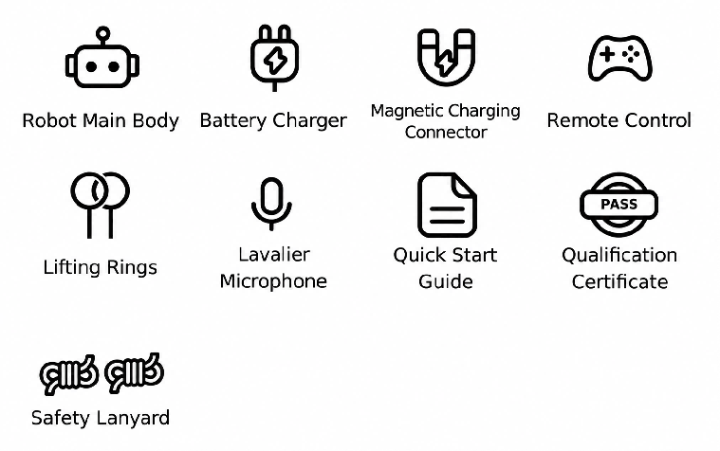
No. | Component Name | Quantity
1 | Robot Main Body | 1
2 | Battery Charger | 1
3 | Magnetic Charging Connector | 1
4 | Remote Control | 1
5 | Lavalier Microphone | 1
6 | Quick Start Guide | 1
7 | Qualification Certificate | 1
8 | Safety Lanyard | 2
9 | Lifting Rings | 2

2.2 Product Introduction
The FF All-New Futurist series products feature 31 to 57 degrees of freedom (varies by model and configuration), enabling flexible movement and high-precision posture control. The following details the specific configuration and functions of the FF All-New Futurist.
• The FF All-New Futurist has a total of 31 active degrees of freedom (excluding hands), with 2 in the neck, 7 per arm, 3 in the waist, and 6 per leg. It is equipped with silicone hands and silicone fists.
• The perception system is equipped with RGB stereo cameras, GPS, UWB positioning, and shoulder touch sensors.
• The communication system is equipped with Wi-Fi, 4G/5G mobile network, and Bluetooth.
• The interaction system is equipped with omnidirectional microphones, speakers, a curved display, and omnidirectional indicator lights.
• The power system is equipped with a 1152Wh battery, providing a total battery life of 10 hours, including 6 hours of standing operation and over 4 hours of continuous walking. It supports both charging and battery changing modes, with a charging time of ≤2 hours.

2.2.1 Component Names and Description

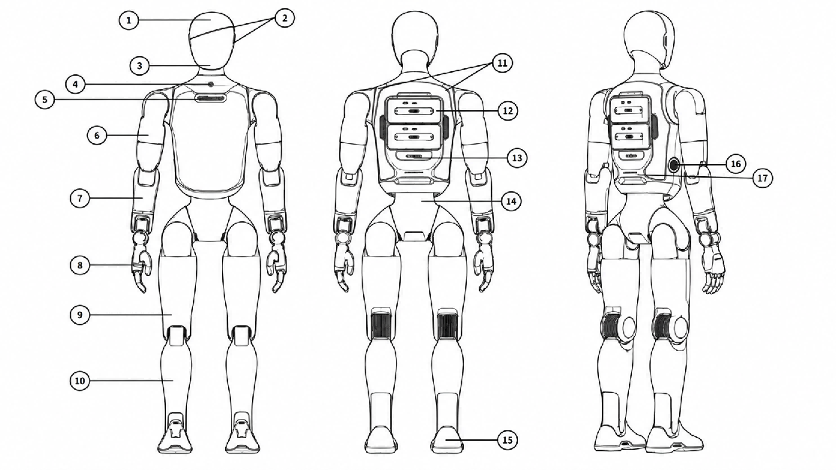
No. | Component | No. | Component | No. | Component
1 | Head Display | 7 | Forearm | 13 | Maintenance Port
2 | Left and Right Speakers | 8 | Hand | 14 | Waist
3 | Interactive Binocular Camera | 9 | Thigh | 15 | Foot
4 | Switch | 10 | Calf | 16 | Charging Port
5 | Microphone | 11 | Shoulder touch sensor | 17 | Waist Handle
6 | Upper Arm | 12 | Dual Battery Compartments

2.2.2 Whole-Body Indicator
The robot displays its current status through the head-screen expression, the chest light, and the ear lights. The chest light is mainly used to indicate the robot's operating, power, and fault status. The ear lights are mainly used to indicate real-time interaction status such as listening and speaking.
Category | Status | Description | Chest Light | Ear Light
Daily | Resting | The robot is lifted and no other status is triggered. | Light off | Light off
 | Standby | The robot is powered on and waiting for user action. | Solid white | Solid white
 | Charging | The robot is charging and the battery is not yet full. | Breathing white | Breathing white
 | Working | The robot is performing tasks such as navigation, narration, delivery, dance, and combat. | Solid white | Solid white
Voice interaction | Listening | The robot is receiving user voice input. | White flowing | White flowing
 | Speaking | The robot is performing voice-interaction tasks such as dialogue, narration, or skill expression.  Note: dance, system broadcast, and client-triggered audio playback are NOT triggered. |  | Solid white
Reminders and Faults | Find Robot | The user is locating the robot through the client. | Red strobe (period ~300 ms)
Reminders and Faults | Severe Fault | A severe fault has occurred. Stop use immediately and inspect it according to the system prompts. | Red flashing (period ~800 ms)
Reminders and Faults | Fault | A fault has occurred and must be handled according to the system prompts. | Solid red
Reminders and Faults | Warning | A condition requiring attention has occurred; for example, when one battery is removed, the robot displays the warning light effect. | Warning light
Reminders and Faults | Device Locked | The robot has entered the locked state.
Reminders and Faults | Low Battery | Either battery is at 15% or below. Recharge or replace promptly. | Breathing red

2.2.3 Battery Indicator
❗ Note: When using battery power, closely monitor the battery level. Low or nearly depleted batteries may cause the robot to topple suddenly due to insufficient power. Recharge or replace the battery immediately when only one indicator remains to maintain stable operation and avoid injury.

2.2.3.1 Location of Battery Indicator Lights

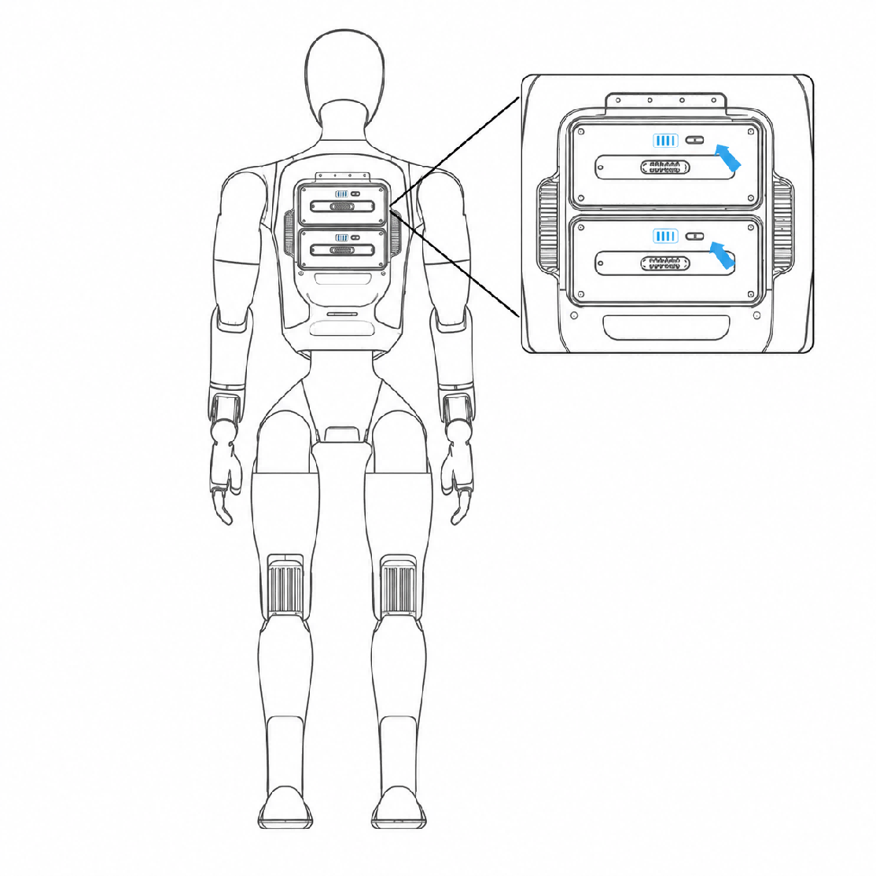

2.2.3.2 Indicator Status Description (Working)
Battery Light Status (Working) | Battery Level | Status Description
All LEDs off | 0% | No power
LED1 on, LEDs 2-4 off | 1% ≤ Battery Level < 25% | Critical Low Power (Recharge Immediately)
LEDs 1-2 on, LEDs 3-4 off | 25% ≤ Battery Level < 50% | Low Power (Plan for Recharge)
LEDs 1-3 on, LED4 off | 50% ≤ Battery Level < 75% | Sufficient power
LEDs 1-4 on | 75% ≤ Battery Level < 100% | Full power

2.2.3.3 Indicator Status Description (Charging)
Battery Light Status (Charging) | Battery Level | Status Description
LED1 breathing, LEDs 2-4 off | Battery Level < 25% | Critical Low Power
LED1 on, LED2 breathing, LEDs 3-4 off | 25% ≤ Battery Level < 50% | Low Power: Do not disconnect
LEDs 1-2 on, LED3 breathing, LED4 off | 50% ≤ Battery Level < 75% | Medium Power: Operable; charge to full recommended
LEDs 1-3 on, LED4 breathing | 75% ≤ Battery Level < 100% | Sufficient Power
LEDs 1-4 on | Battery Level = 100% | Charging Complete

2.2.4 User Debugging Interfaces
No. | Hardware Expansion Interface | Interface | Description
1 | Maintenance bay: for debugging and secondary development | USB Type-A 2.0 (lumbar) | Supports MDU serial reading and debugging.
2 | Maintenance bay: for debugging and secondary development | USB Type-C (head) | Supports head HDU (RK3588s) debugging and secondary development. Supports connecting a microphone receiver.
3 | Power interface | USB Type-C | 5 V / 3 A output; can charge external devices such as the remote controller.

2.3 Robot Joint Motion Range
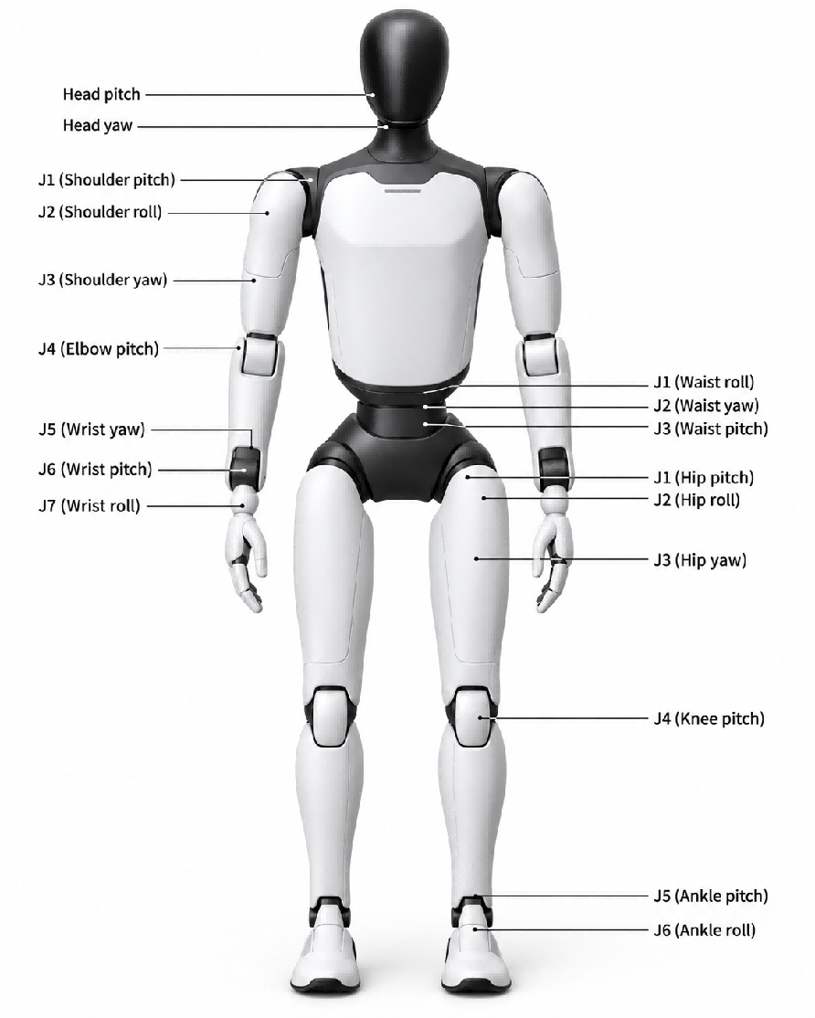
Joint Name | Joint Limit | Joint Name | Joint Limit
Arm | J1(Shoulder pitch): -165°～165° | Waist | J1(Waist roll): ±20°
 | J2(Shoulder roll): -5°~150° |  | J2(Waist yaw): ±150°
 | J3(Shoulder yaw): ±160° |  | J3(Waist pitch): -28°~24°
 | J4(Elbow pitch): -55°~100° | Leg | J1(Hip pitch): -144°~168°
 | J5(Wrist roll): ±160° |  | J2(Hip roll): -30~85°
 | J6(Wrist pitch): ±93° |  | J3(Hip yaw): ±156°
 | J7(Wrist yaw): ±93° |  | J4(Knee pitch): -7°~145°
Head | Tilt joint (Head pitch): 15° (down), 25° (up) |  | J5(Ankle pitch): -52°~30°
 | Rotation joint (Head yaw): ±60° |  | J6(Ankle roll): ±20°

Note: Joint Limits are calculated based on structural design parameters. Individual differences may exist between devices, and these data are for reference only.

2.4 Robot Sensor Field of View
Robot Model | Configuration | Capability
FF All-New Futurist | Interactive Binocular Camera | Interactive Binocular Camera: Supports visual recognition and response in human-robot interaction scenarios

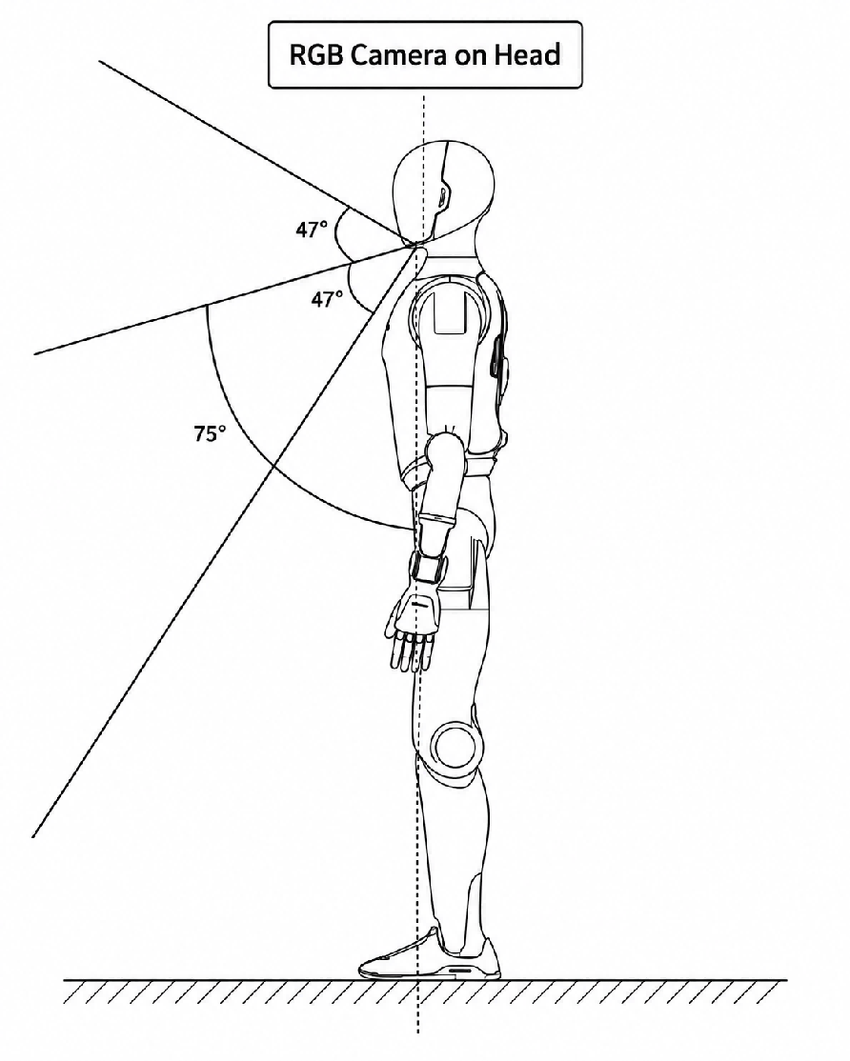

2.5 Robot Specifications
Robot Specifications |  | Details
Main Body | Height | 1.73 m
 | Dimensions | 173 cm (H) x 52 cm (W) x 30 cm (L)
 | Weight | 55 KG
 | Active Degrees of Freedom | 31
 | Neck Degrees of Freedom | 2
 | Single Arm Degrees of Freedom | 7
 | Waist Degrees of Freedom | 3
 | Single Leg Degrees of Freedom | 6
Perception System | 3D LiDAR | /
 | Embodied Operation RGB-D Camera | /
 | Terrain Perception RGB-D Camera | /
 | Interactive RGB Camera | RGB Binocular Camera
 | Panoramic RGB Camera | /
 | GPS | Equipped
 | GPS RTK | /
 | UWB Positioning | Equipped
 | Shoulder Touch Sensors | Equipped
Communication | Communication Methods | WiFi, 4G/5G Network, Bluetooth
Interaction | Microphone | Omnidirectional Microphone  Front and Rear 8-Microphone Array
 | Speaker | Equipped
 | Face Screen | Curved Screen
 | Indicator Lights | Omnidirectional Indicator Lights
Performance | Knee Joint Peak Torque | 320 N·m
 | Movement Speed | Max Daily Walking Speed: 1.8 m/s  Normal Daily Walking Speed: ＜ 1.2 m/s  Maximum Laboratory Speed: 2.5 m/s  Max Running Speed: 5 m/s
 | Single Arm Payload | 5 kg
Operating Environment | Operating Temperature | -10°C to +45°C
Power and Energy | Battery Capacity | 1152 W·h
 | Battery Life | 10 hour  * measured with standing / walking ratio = 1:1.  * Battery life measurement is affected by walking speed and load.
 | Charging Methods | Supports direct charging and battery swapping
 | Charging Time | ≤2 hour
 | Charging Input Voltage | 110-220 V
Computing Power | Basic Computing Board | RK3588 * 2
 | Advanced Computing Board | /
Others | Wireless Remote Control | Equipped
 | OTA Update | Supported
 | Further Development | Supported

2.6 Radio Frequency Specifications
Wi-Fi and Bluetooth
• 2.4 GHz Wi-Fi: 20 dBm (EIRP)
• Bluetooth: 20 dBm (EIRP)
• 5 GHz Wi-Fi:
◦ 5150–5250 MHz: 23 dBm (EIRP)
◦ 5725–5850 MHz: 14 dBm (EIRP)
Wi-Fi operation in the 5150–5250 MHz frequency range is restricted to indoor use in all EU/EFTA member states and Turkey.
UWB
• 7987.2 MHz: 0 dBm (EIRP)
Cellular Bands
• LTE Band 1: Uplink: 1920–1980 MHz; Downlink: 2110–2170 MHz
• LTE Band 3: Uplink: 1710–1785 MHz; Downlink: 1805–1880 MHz
• LTE Band 7: Uplink: 2500–2570 MHz; Downlink: 2620–2690 MHz
• LTE Band 8: Uplink: 880–915 MHz; Downlink: 925–960 MHz
• LTE Band 20: Uplink: 832–862 MHz; Downlink: 791–821 MHz
• LTE Band 28: Uplink: 703–748 MHz; Downlink: 758–803 MHz
• LTE Band 32: Downlink only: 1452–1496 MHz
• LTE Band 34: Uplink and downlink: 2010–2025 MHz
• LTE Band 38: Uplink and downlink: 2570–2620 MHz
• LTE Band 40: Uplink and downlink: 2300–2400 MHz
• LTE Band 41: Uplink and downlink: 2496–2690 MHz
• LTE Band 42: Uplink and downlink: 3400–3600 MHz
• LTE Band 43: Uplink and downlink: 3600–3800 MHz
• LTE Band 46: Downlink only: 5150–5925 MHz
5G NR Bands
• NR n1: Uplink: 1920–1980 MHz; Downlink: 2110–2170 MHz
• NR n3: Uplink: 1710–1785 MHz; Downlink: 1805–1880 MHz
• NR n7: Uplink: 2500–2570 MHz; Downlink: 2620–2690 MHz
• NR n8: Uplink: 880–915 MHz; Downlink: 925–960 MHz
• NR n20: Uplink: 832–862 MHz; Downlink: 791–821 MHz
• NR n28: Uplink: 703–748 MHz; Downlink: 758–803 MHz
• NR n38: Uplink and downlink: 2570–2620 MHz
• NR n40: Uplink and downlink: 2300–2400 MHz
• NR n41: Uplink and downlink: 2496–2690 MHz
• NR n75: Downlink only: 1432–1517 MHz
• NR n76: Downlink only: 1427–1432 MHz
• NR n77: Uplink and downlink: 3300–4200 MHz
• NR n78: Uplink and downlink: 3300–3800 MHz
Maximum Transmit Power
• LTE bands: 23 dBm (+2.0/-2.0 dB)
• 5G NR Power Class 3, bands n1/n3/n7/n8/n20/n28/n38/n40: 23 dBm (+2.0/-2.0 dB)
• 5G NR Power Class 2, bands n41/n77/n78: 26 dBm (+3/-4 dB)

3. Introduction to Remote Control

3.1 Remote Control Exterior Design
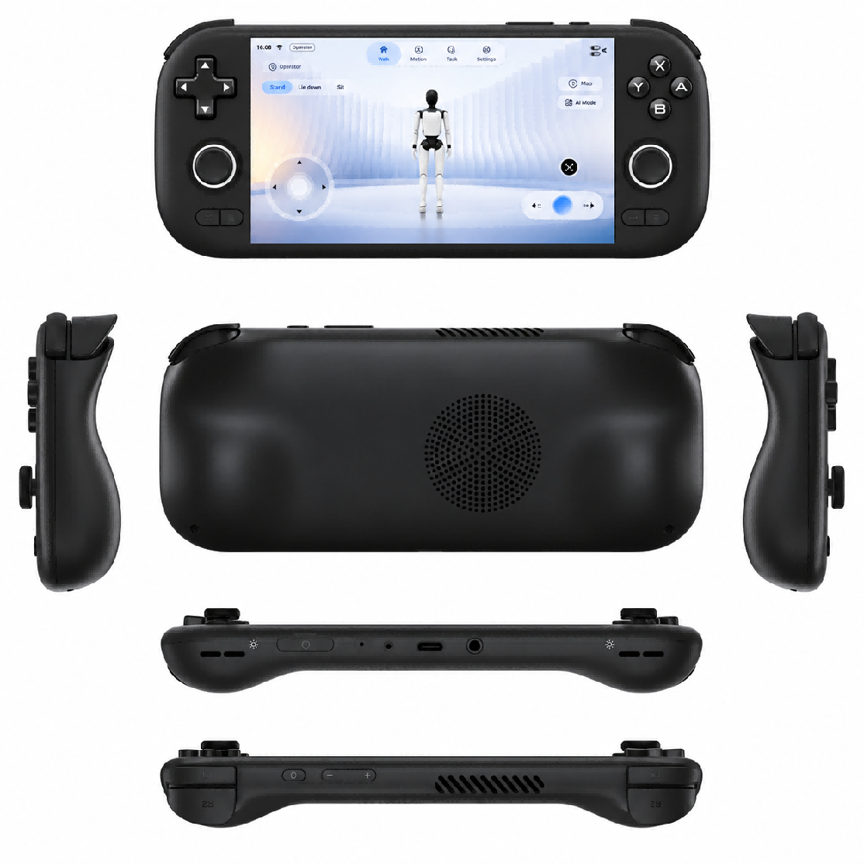

3.2 Remote Control Button Layout
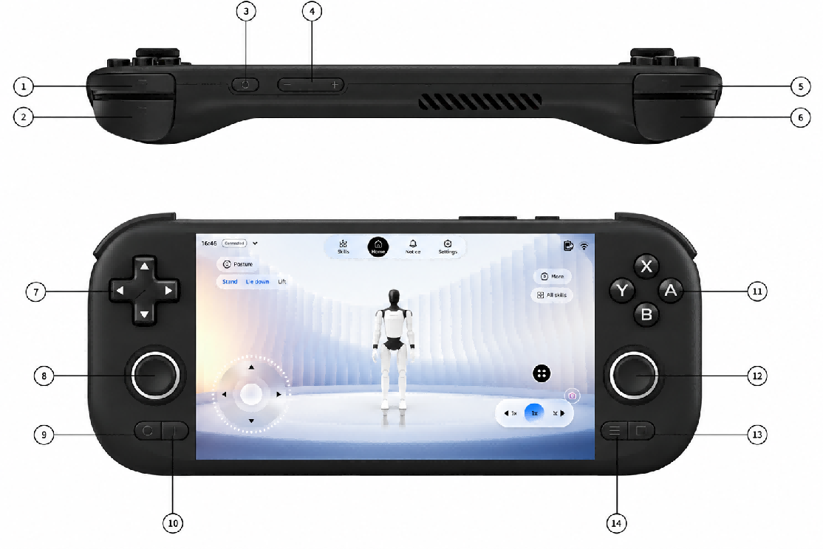
No. | Name | No. | Name
1 | Left Trigger (L2) | 8 | Left Joystick (L3)
2 | Left Shoulder Button (L1) | 9 | Back
3 | Power Button | 10 | Home
4 | Volume | 11 | A/B/X/Y
5 | Right Trigger (R2) | 12 | Right Joystick (R3)
6 | Right Shoulder Button (R1) | 13 | Start
7 | D-Pad | 14 | Select

3.3 Remote Control Charging Instructions
Charging Method: The remote control supports charging via a USB-C cable. Do not use a high-power charger, as this may degrade the remote control's performance.
Battery Life: The remote control typically lasts about 4 hours on a single charge. A full charge takes 3-4 hours. Actual battery life is affected by various factors, and the specific duration depends on actual usage.
❗ Precautions:
1. When using the remote control to operate the Robot, closely monitor the Robot's battery level. Low battery may prevent switching motion control modes, which could lead to the Robot falling unexpectedly.
2. Use a charger that meets safety standards to charge the remote control. It is recommended to use a 5V/1A or 5V/2A charger to prevent damage from overcharging.

4. Usage Instructions

4.1 App Interface

4.1.1 General Guide (How to Connect the Robot)
Step 1: Language Selection (Required for First Connection)
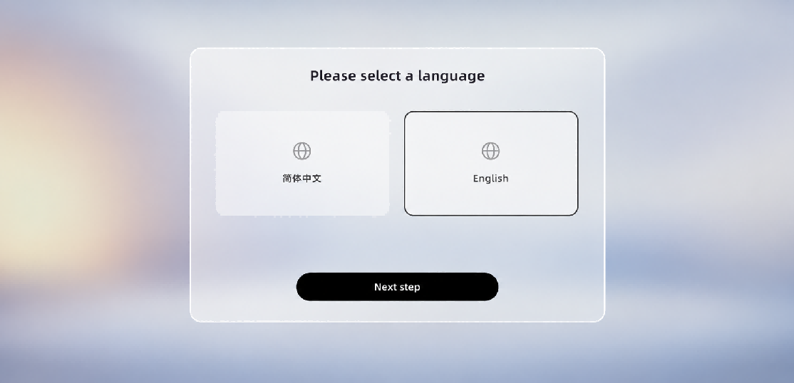
Step 2: Privacy & User Agreement (Required for the first connection)
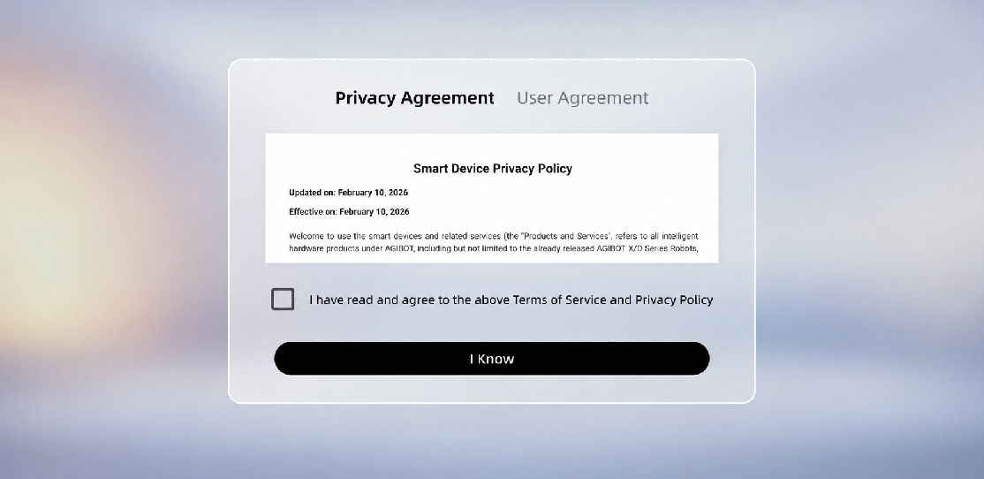
Step 3: Lock screen password setting (required for the first connection)
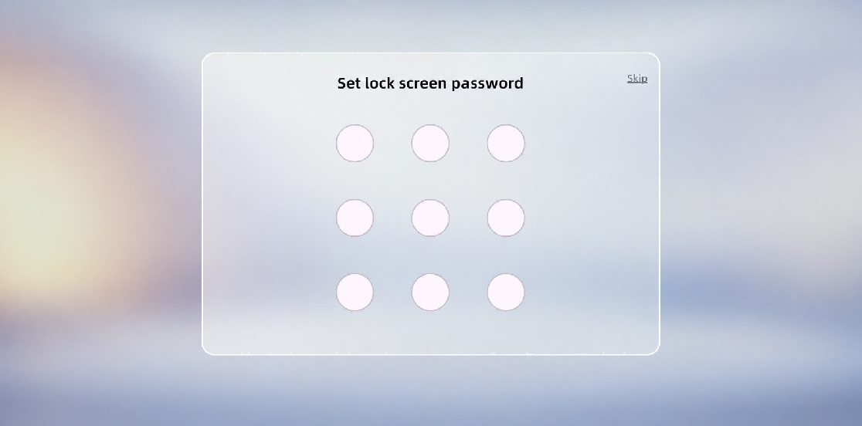
Step 4: Select the robot type
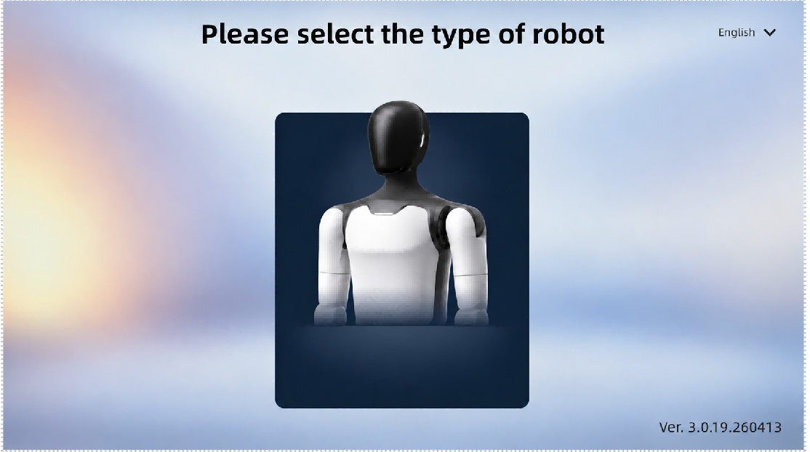
Step 5: Turn on the power
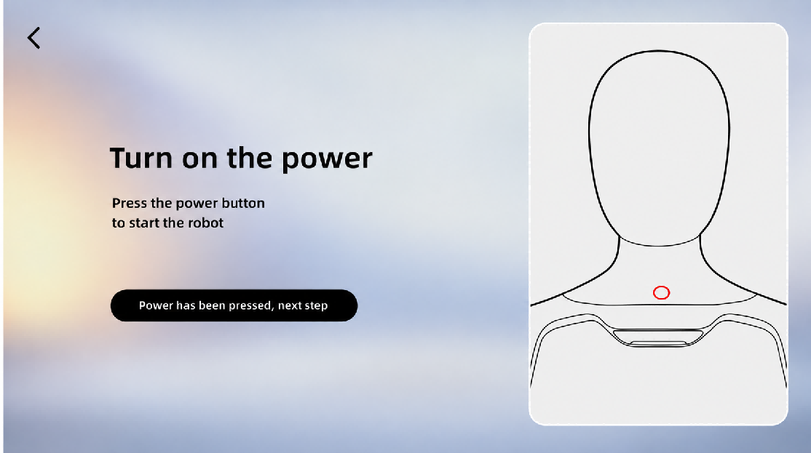
Step 6: Network connection (required for the first connection)
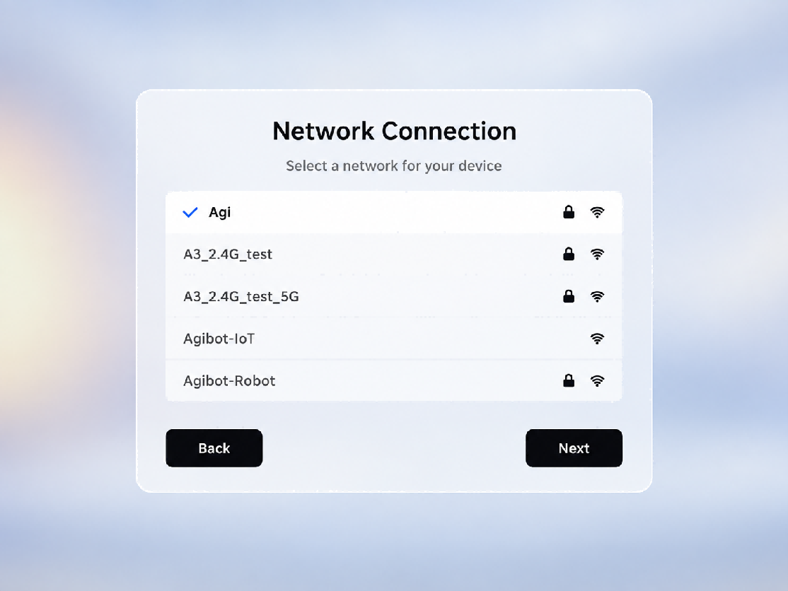
Step 7: Select the robot's language and location (required for the first connection)
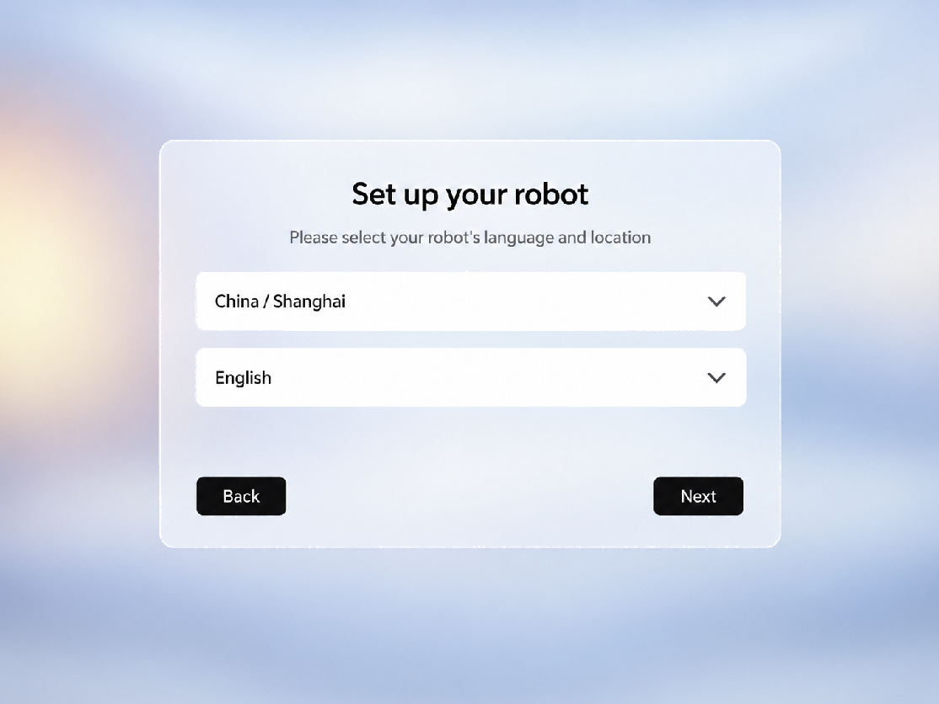
Step 8: Robot authorization password (required for the first connection)
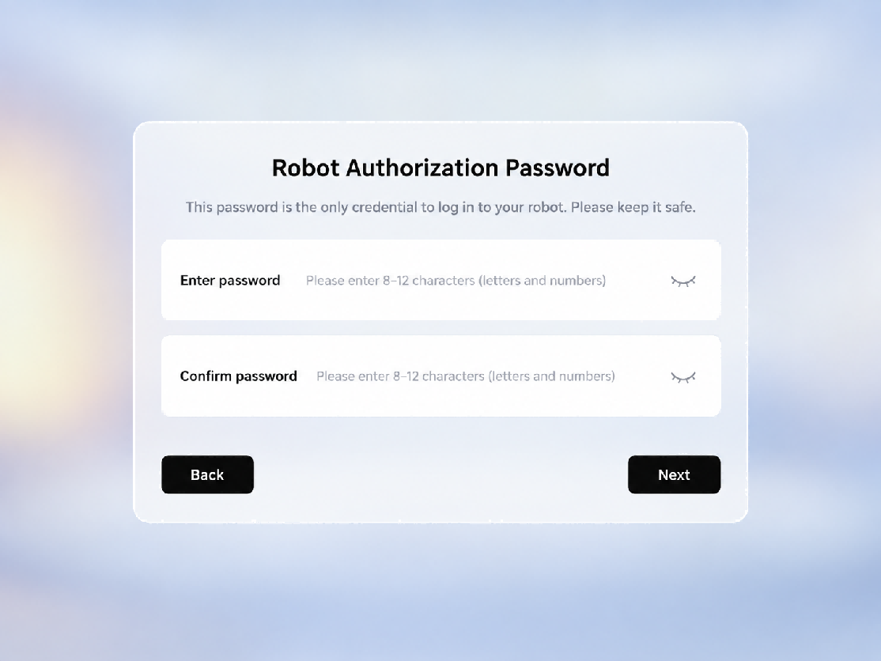
Step 9: Select the robot's posture
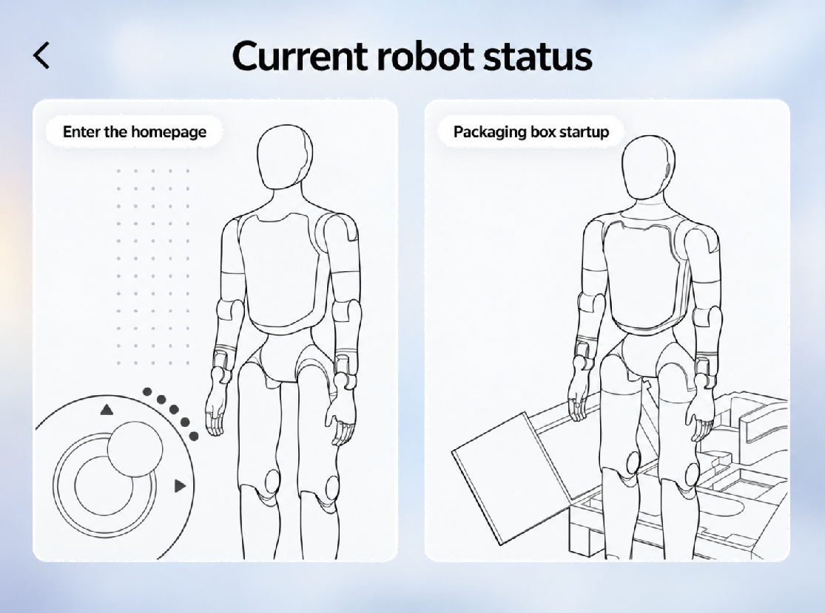
Step 10: Enter the home page

4.2 Startup Process

4.2.1 Packaging Machine Startup
Step 1: Activate the battery
❗ Note:
This activation step is only required when opening the package for the first time or when the battery pack is in storage and transportation mode.

Stand the packaging box upright, open the bottom window, short press and then long press the power button of each of the two battery packs, until all the indicator lights of the battery packs light up in sequence, indicating successful activation, and then close the bottom window.
Step 1-1: Stand up the packing box and open the bottom window  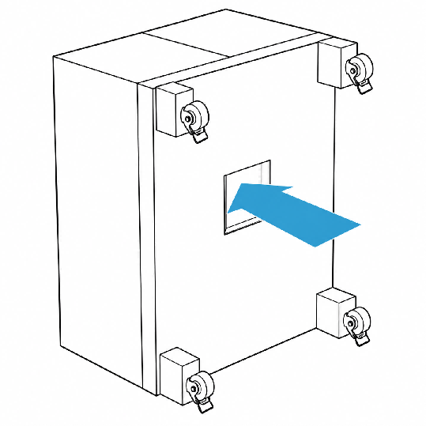 | Step 1-2: Activate two battery packs  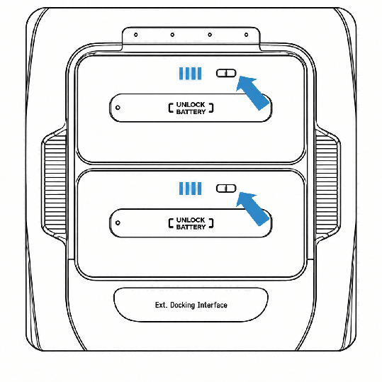

Step 2: Open the package
Lay the packing box flat, lock the wheels at the bottom of the packing box after confirming that there are no obstacles in front, then open the top cover of the packing box and remove the middle layer and hip-cover foam, ensuring that there are no items above the robot.
Step 2-1: Place the packing box flat  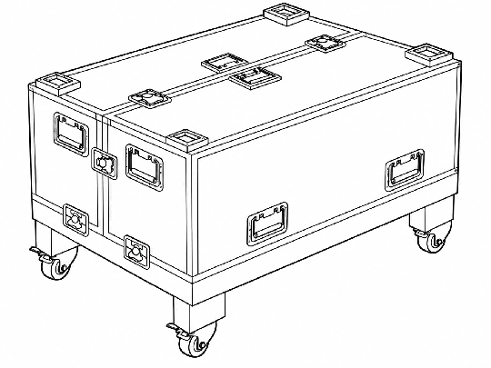 | Step 2-2: Lock the wheels at the bottom of the packing box  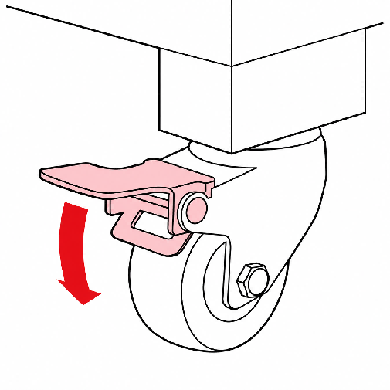

Step 2-3: Unlock and open the top cover of the packaging box  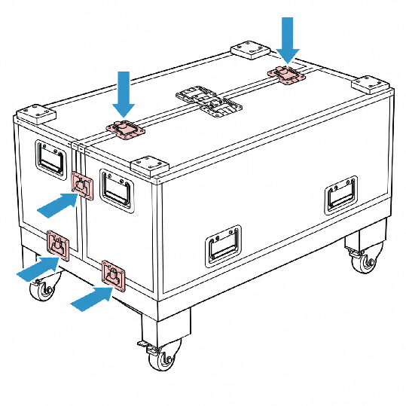 | Step 2-4: Remove the middle layer and hip-cover foam  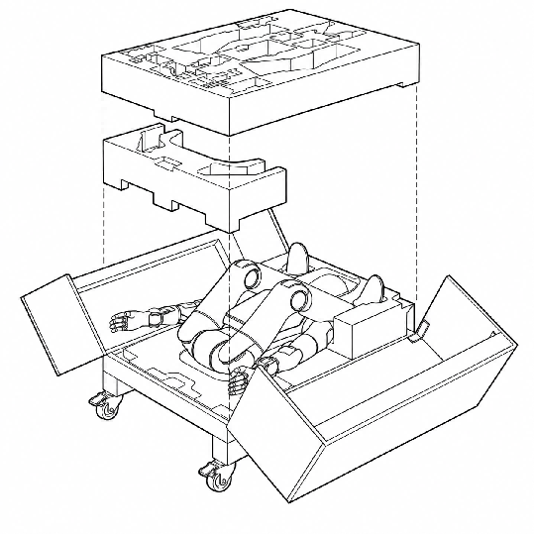

Step 3: Power on and start
Press and hold the robot's power button to turn on the robot. After the robot is powered on, the head screen and the indicator light on the chest will light up.
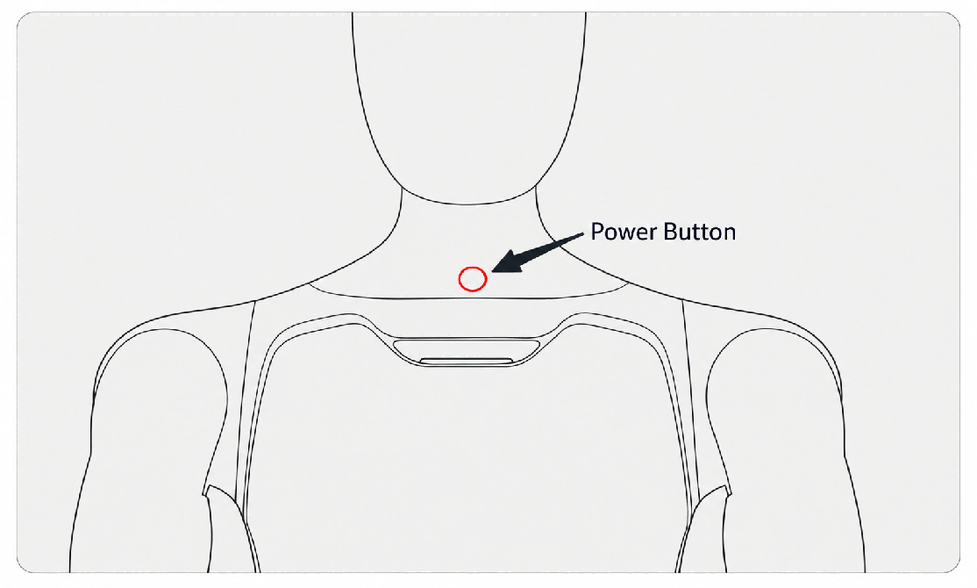
Step 4: Connect to the App
Complete the connection between the App and the robot according to the steps in Section 4.1, and select the Packing Box startup option on the robot status page
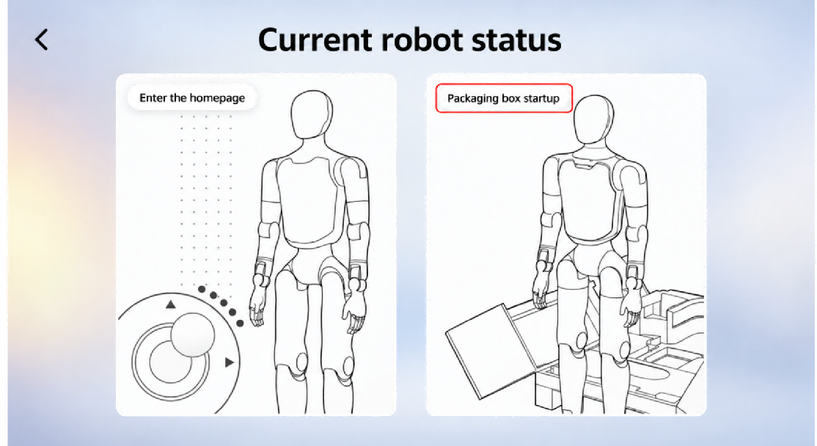
Step 5: Stand up inside the box
After confirming the environment step by step in the App, control the robot to stand up from the box with one click. The robot will then enter the motion state and maintain a stable standing posture.
❗ Note:
• Ensure no obstacles are present in front of the packaging box.
• Lock all casters of the box securely.
• Make sure the robot's hip position is above the red line; adjust it manually if not.
• After the robot stands up, move the packaging box at least 0.5 meters away before operation.

Operation Steps | Operation Interface
Ensure the packaging box is placed steadily with no obstacles ahead | 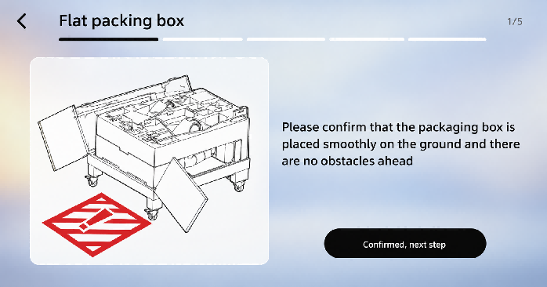
Confirm the box casters are locked | 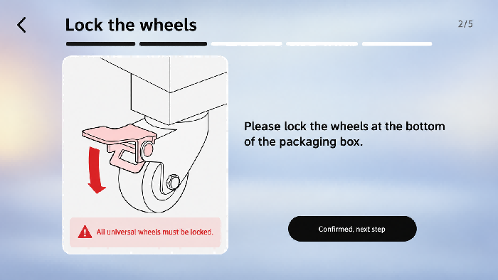
Confirm the middle layer and hip-cover foam is removed | 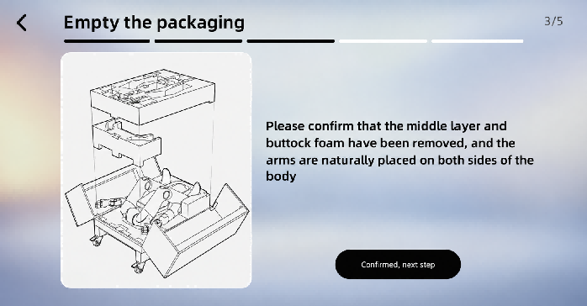
Confirm that the robot's position is correct | 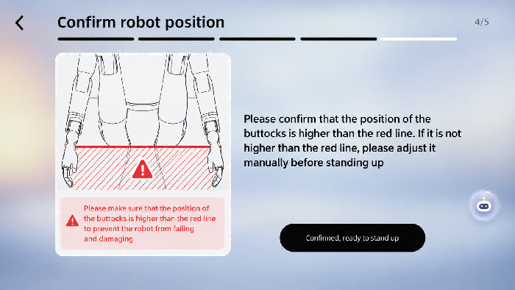
Confirm initiating the robot stand-up | 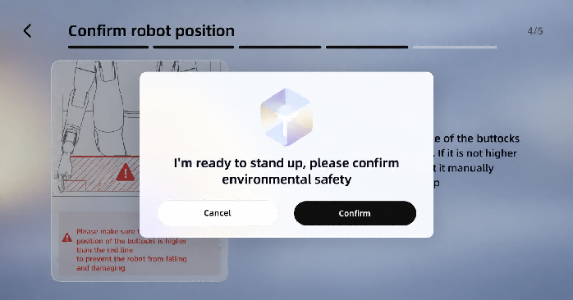
Robot standing up (automatic) | 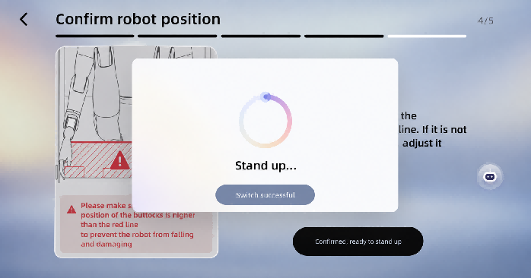
The robot successfully stands up, moves the packing box away, and ready to use | 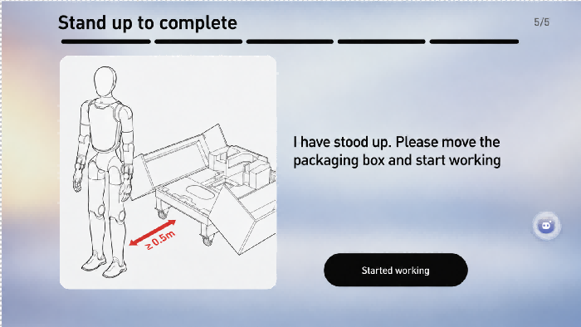

4.2.2 Power On in Supine Position
Step 1: Power on and start
Press and hold the robot's power button to turn on the robot. After the robot is powered on, the head screen and the indicator light on the chest will light up.
❗ Note:
If the battery pack is in storage and transportation mode, it is necessary to activate the battery pack before powering on. The operation method is to short press and then long press (1s) the power button on the battery pack, until all the battery pack indicator lights light up sequentially.

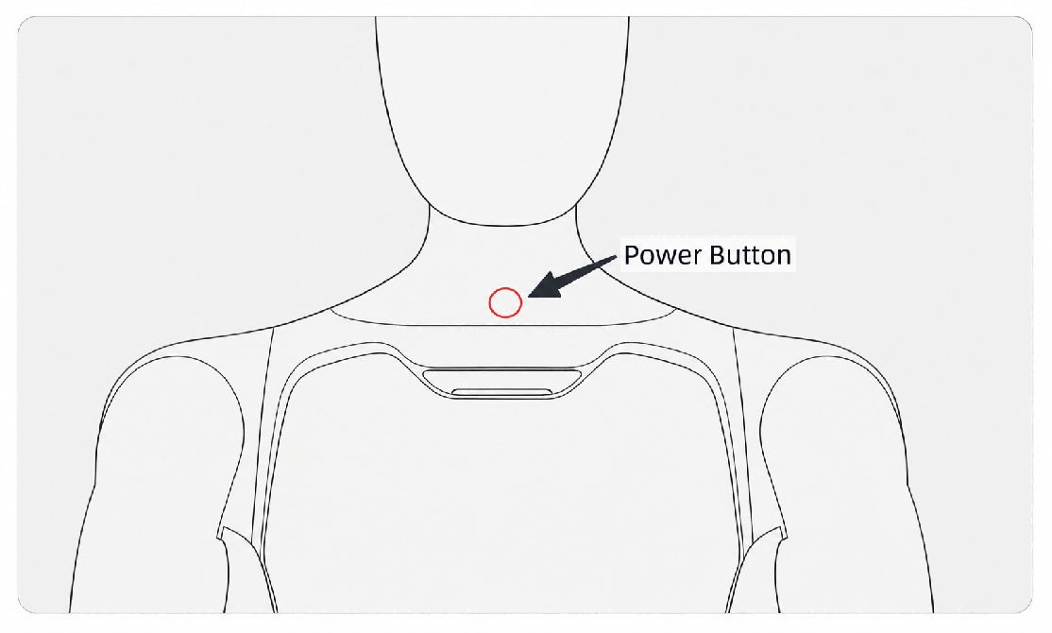
Step 2: Lay the robot flat
Lay down the robot on a flat surface as shown in the following illustration, ensuring that the entire body of the robot faces upward, its limbs are extended, and its arms are naturally placed on both sides of the body.
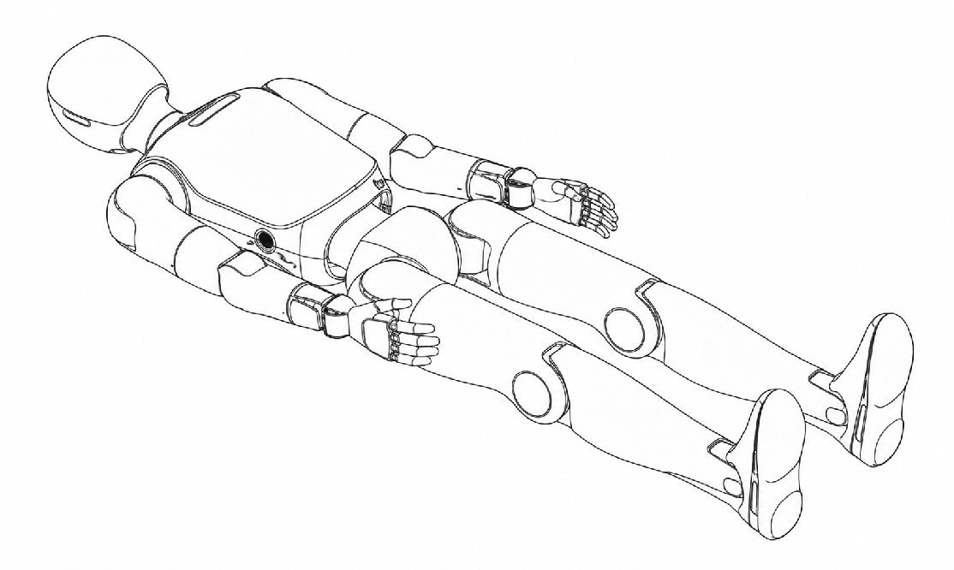
Step 3: Connect to the App
Complete the connection between the App and the robot according to the steps in Section 4.1, and select the homepage entering option on the robot status page.
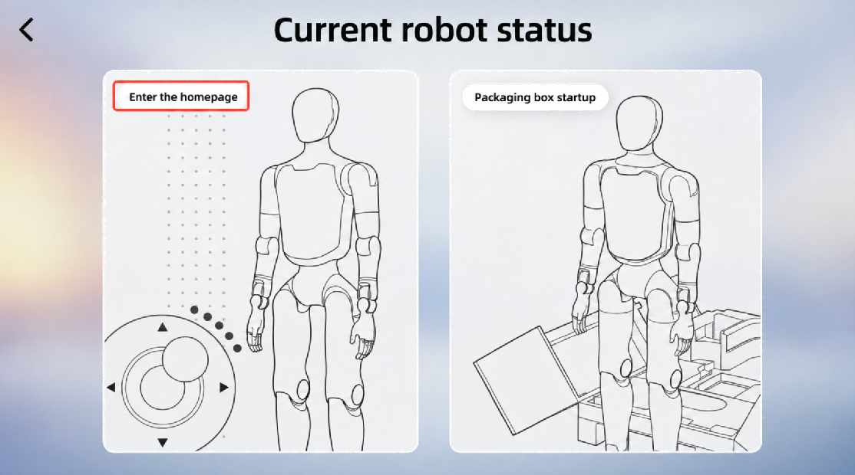
Step 4: Confirm environmental safety
Before triggering the lying-down-to-standing-up action, it is necessary to ensure that there are no foreign objects within a 1-meter radius around the robot to reserve sufficient safety space for the action execution.
Step 5: Stand up from lying flat
Under the Posture switch on the home page of the App, choose "Stand" to enable the robot to stand up from a lying position. At this time, the robot enters a motion state and stands stably.
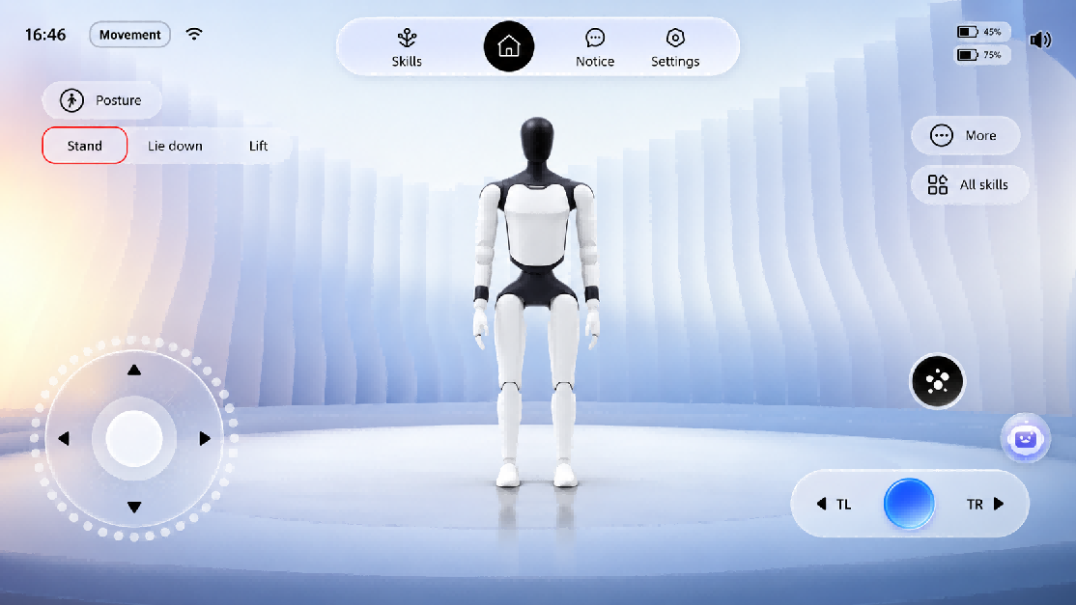

4.2.3 Power On in Prone Position
Step 1: Power on and start
Press and hold the robot's power button to turn on the robot. After the robot is powered on, the head screen and the indicator light on the chest will light up.
❗ Note:
If the battery pack is in storage and transportation mode, it is necessary to activate the battery pack before powering on. The operation method is to short press and then long press (1s) the power button on the battery pack, until all the battery pack indicator lights light up sequentially.

Step 2: Lay the robot face-down
Lay the robot face-down on a flat surface as shown in the illustration, ensuring that the entire body of the robot faces downward, its limbs are extended, and its arms are naturally positioned on both sides of the body.
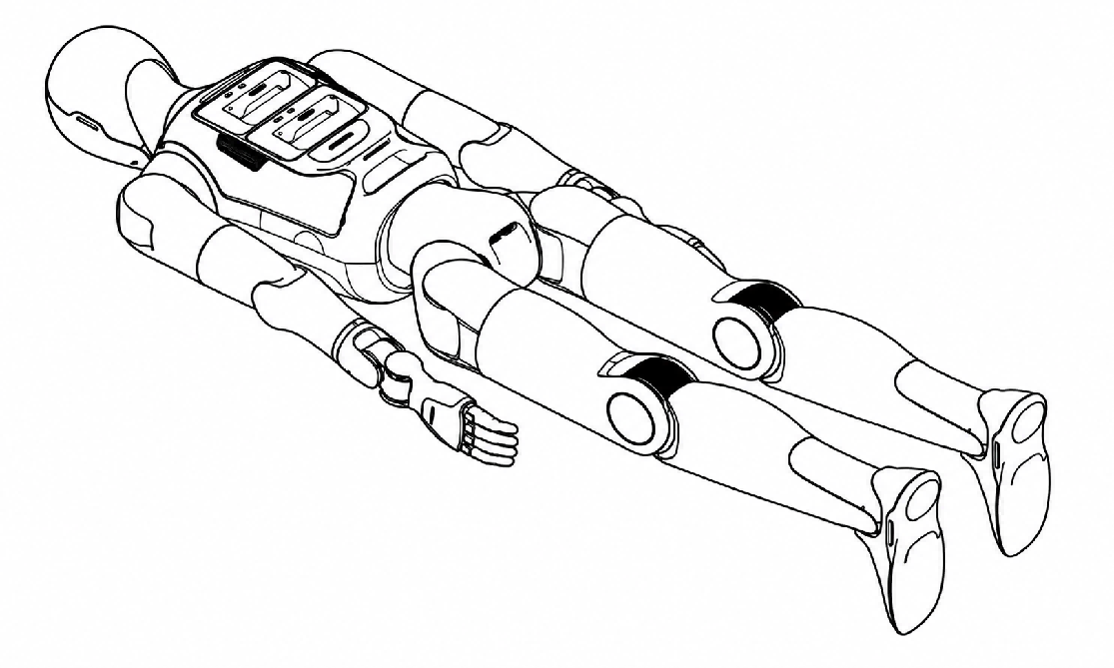
Step 3: Connect to the App
Complete the connection between the App and the robot according to the steps in Section 4.1, and select the homepage entering option on the robot status page.
Step 4: Confirm environmental safety
Before triggering the prone-to-standing action, it is necessary to ensure that there are no foreign objects within a 1-meter radius around the robot to reserve sufficient safety space for the action execution.
Step 5: Stand up from a prone position
Under the Posture switch on the home page of the App, choose "Stand" to enable the robot to stand up from a lying position. At this time, the robot enters a motion state and stands stably.

4.3 Shutdown Process

4.3.1 Shutdown and Packing
❗ Note:
• When moving the packing box to align with the robot, be sure not to hit the robot;
• Before the robot enters the packaging, confirm that all casters have been locked.

Step 1: The robot is in motion and standing stably
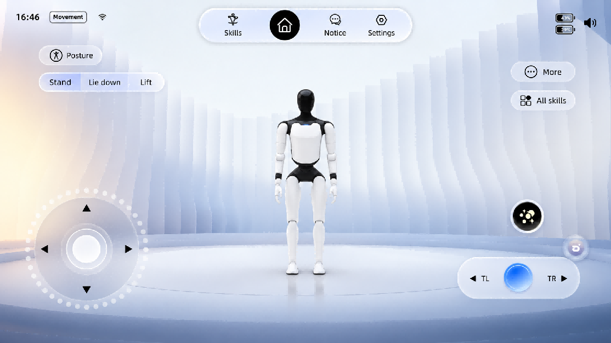
Step 2: Initiate the self-service return process
On the <Settings> - <Packing> page of the App, choose <Autonomous return to Box>, and start the return-to-box process after ensuring the surface is level.
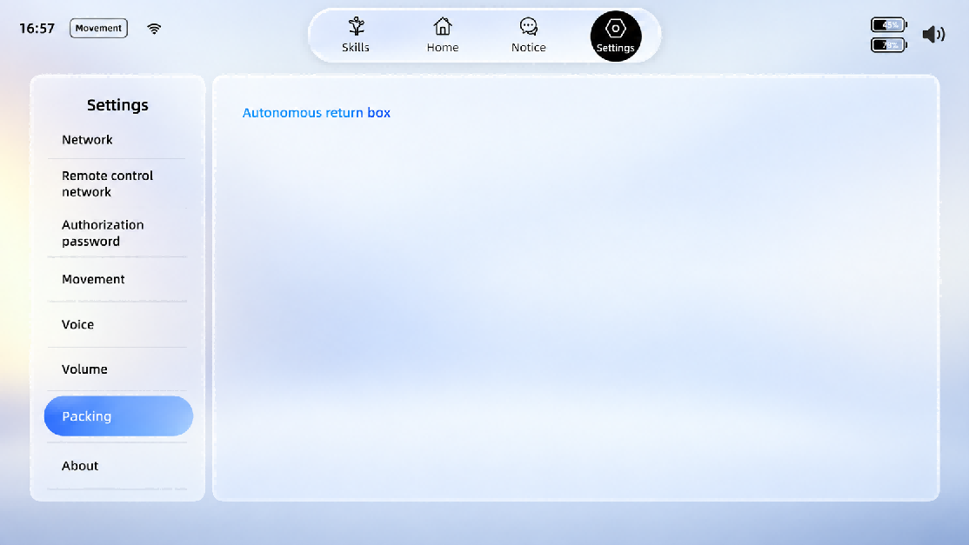
Step 3: Move and position the packaging box
Pull out the positioning block from inside the packing box, turn it over to the outer wall of the packing box and press it firmly against the wall; move the packing box to the back of the robot so that the positioning block gently touches both legs and centers itself for positioning.
Step 3-1: Flip out the positioning block  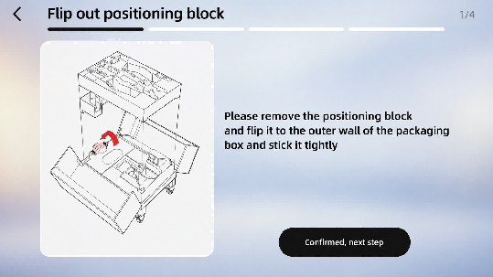 | Step 3-2: Align the robot  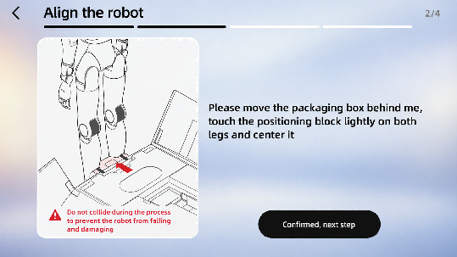

Step 4: Lock the packing box
Lock all the casters of the packing box, and confirm that the inside of the packing box has been cleaned up.
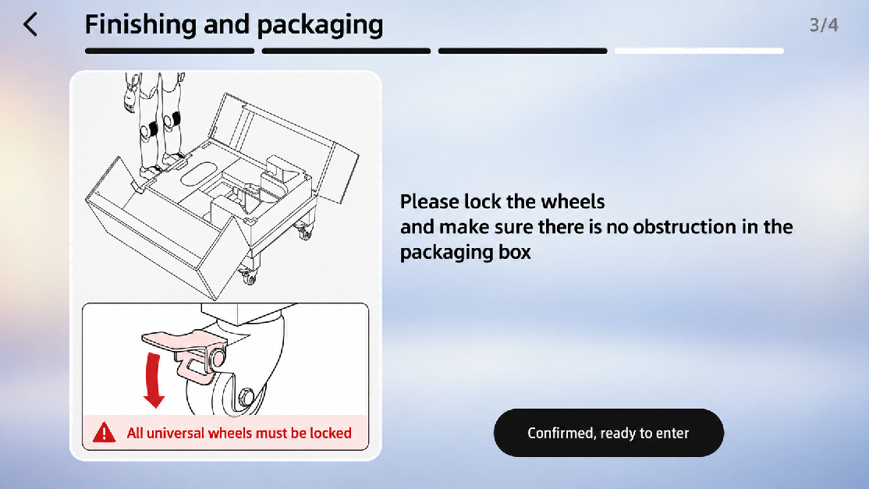
Step 5: Robot returns to the box
After confirming environmental safety, confirm to start entering the packaging box.
Step 6: Shut down and pack
After the robot is placed inside the packaging box, briefly press the power button on the chest, and follow the voice prompts to turn it off; then insert the positioning block, hip-cover foam, and middle layer foam back into their original positions to secure and protect the robot; finally, close the packaging box and lock it.

4.3.2 Shutdown with Supine Position
❗ Caution: Ensure a 1-meter radius safety space around the robot to avoid collisions.

Step 1: The robot is in motion mode, use the remote control to connect to the robot
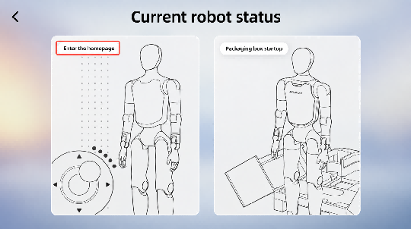 | 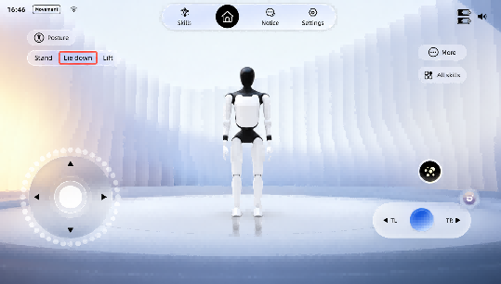

Step 2: Remote control the robot to lie flat

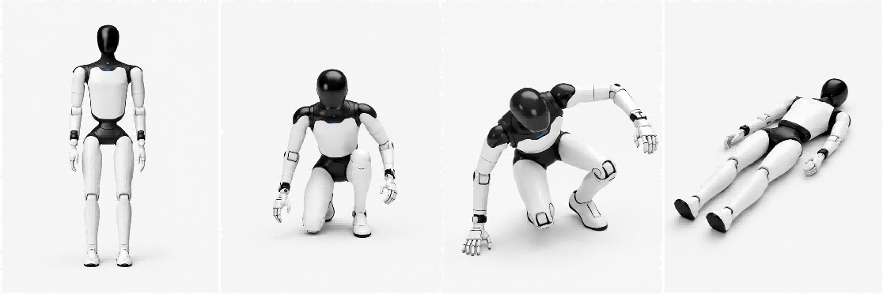
Step 3: Short press the power button on the chest, and follow the voice prompts to turn off the device
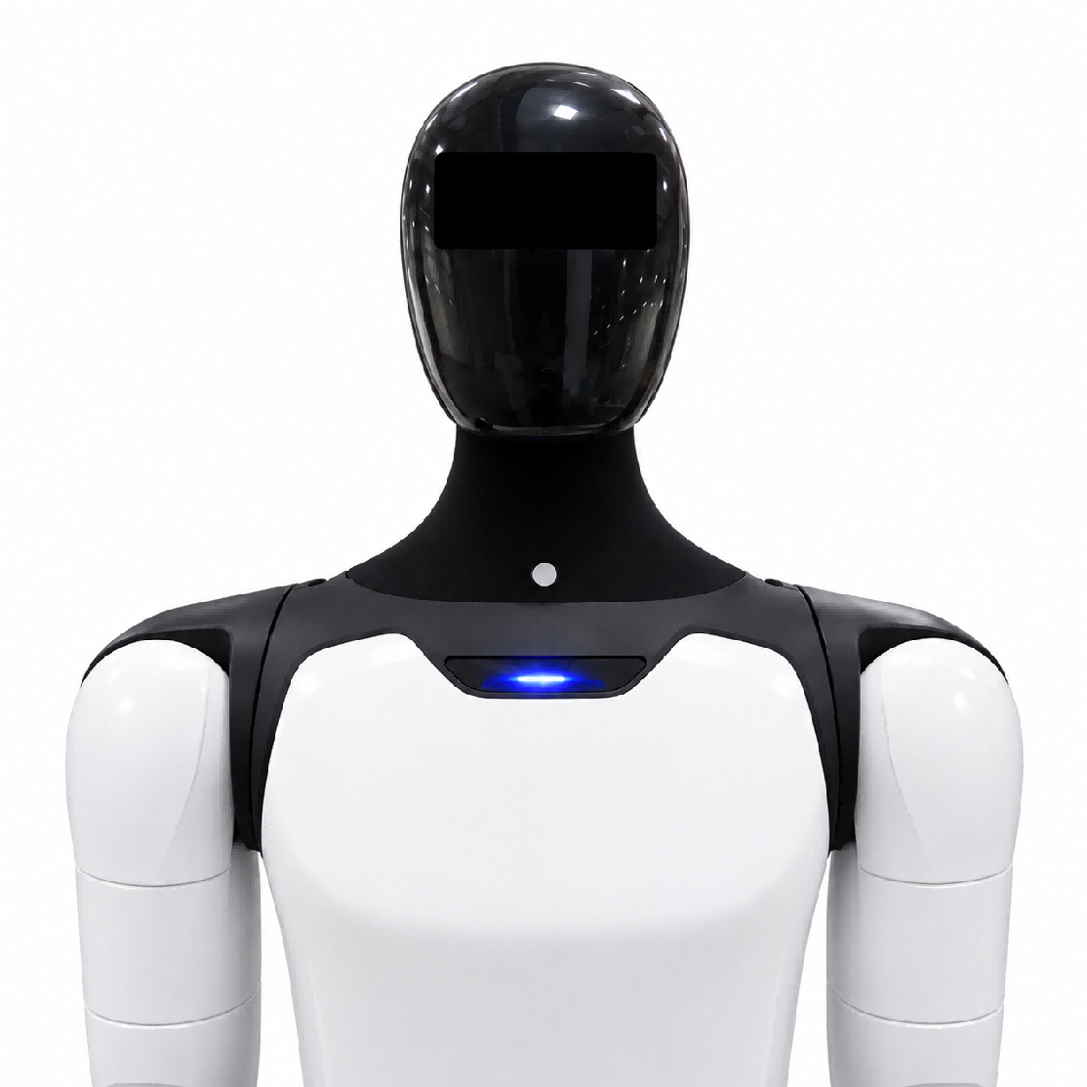

4.4 Entering and Exiting Battery Pack Storage Mode
⚠️ Note: Before transportation or long-term storage, it is recommended to enable the battery pack storage mode. If the robot is powered off without entering Storage Mode, the system will still consume approximately 7W of standby power, and a fully charged battery pack may be completely depleted in about 7 days.

4.4.1 Enter Storage Mode
Step 1: Press the battery pack power button briefly 5 times continuously. After the red indicator starts flashing, press and hold the power button.
Step 2: Continue holding the button until the green indicator starts flashing, then release the button. The battery pack has now entered Storage Mode.
Storage Mode Activation Check:
Briefly press the battery pack power button once. If the battery indicator lights up only after a few seconds, Storage Mode has been successfully activated.

4.4.2 Exit Storage Mode
Step 1: Briefly press the battery pack power button once to make all green indicators light up, and perform the Storage Mode check.
Step 2: Immediately press and hold the power button again. When the indicator light sequence completes, the battery pack has been successfully activated and has exited Storage Mode.

4.5 Charging and Battery Changing

4.5.1 Charging Mode
1. Charging the robot with battery installed
When both batteries are in place, the magnetic charging head of the charger can be connected to the charging port of the robot. After the power is turned on, the magnetic charging head of the charger lights up green, indicating successful charging. The schematic diagram is as follows:
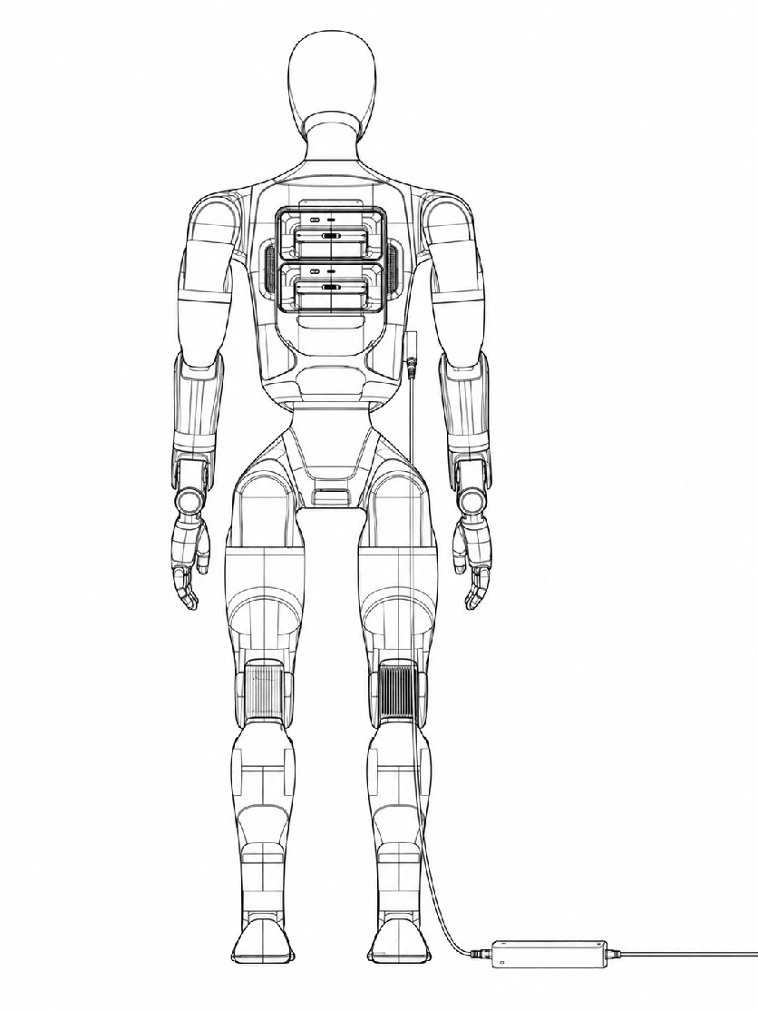
2. Charging the battery solely
Remove the battery and separate the magnetic adapter section of the charger to directly charge the battery. The schematic diagram is as follows:
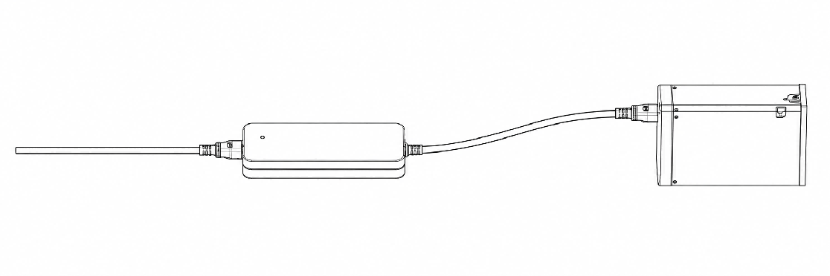

4.5.2 Battery Changing Mode
❗ Note:
If the battery pack is in storage and transportation mode, it is necessary to activate the battery pack before powering on. The operation method is to short press and then long press (1s) the battery pack power button until all the battery pack indicator lights light up sequentially.

Step 1: Remove an individual battery
Step 2: Insert the "new" battery
Step 3: Repeat the above actions and replace the second battery
* Individual battery can be removed in both the shutdown state and the powered-on standing state (when only a single battery is left in place, the robot is restricted from moving)
❗ Note:
If the battery pack is in storage and transportation mode, it is necessary to activate the battery pack before powering on. The operation method is to short press and then long press (1s) the battery pack power button until all the battery pack indicator lights light up sequentially.

4.6 Emergency Stop Function
The emergency stop function is used for the emergency stop of the robot in case of sudden situations, preventing further damage to the robot or the surrounding environment, and can be triggered in the "software emergency stop" mode.
After the robot enters the emergency stop state, its limbs will lose power and fall to the ground, with a certain risk of damaging the machine. Please ensure that users use the emergency stop function with extreme caution.

4.6.1 Soft Emergency Stop
1. Steps to trigger the emergency stop state
◦ Method 1: Triggered via the App
Operation Steps | Operation Interface
Press the floating ball to enter the emergency stop page | 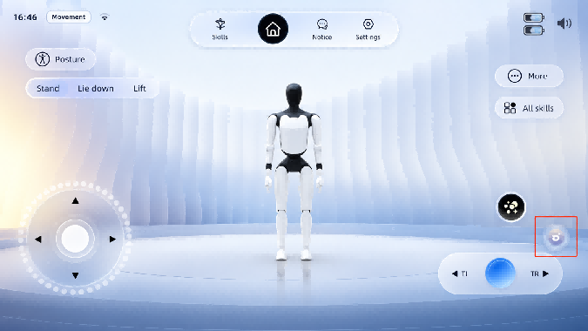
Press and hold the [Emergency Stop] button, then slide it to the right until it reaches the end to trigger a soft emergency stop | 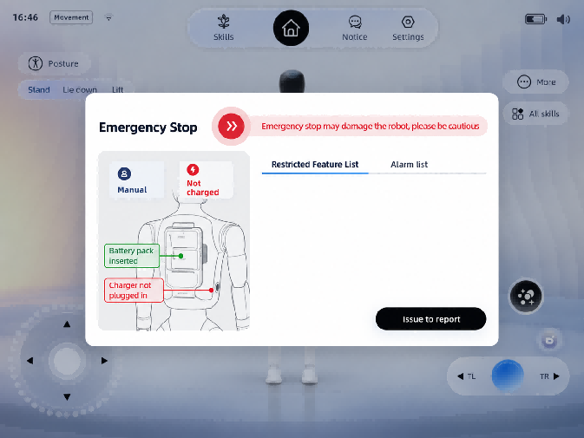
Enter the soft emergency stop state | 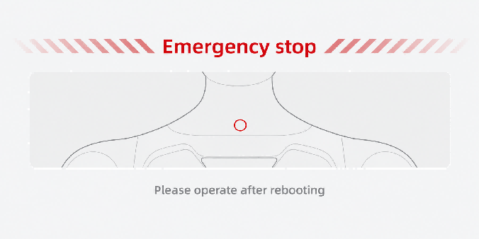

◦ Method 2: Triggered by remote control buttons (applicable to remote controls)
When the remote control is connected to the robot, hold the four buttons L1+L2+R1+R2 at the same time for more than 0.5 seconds to trigger the soft emergency stop state.
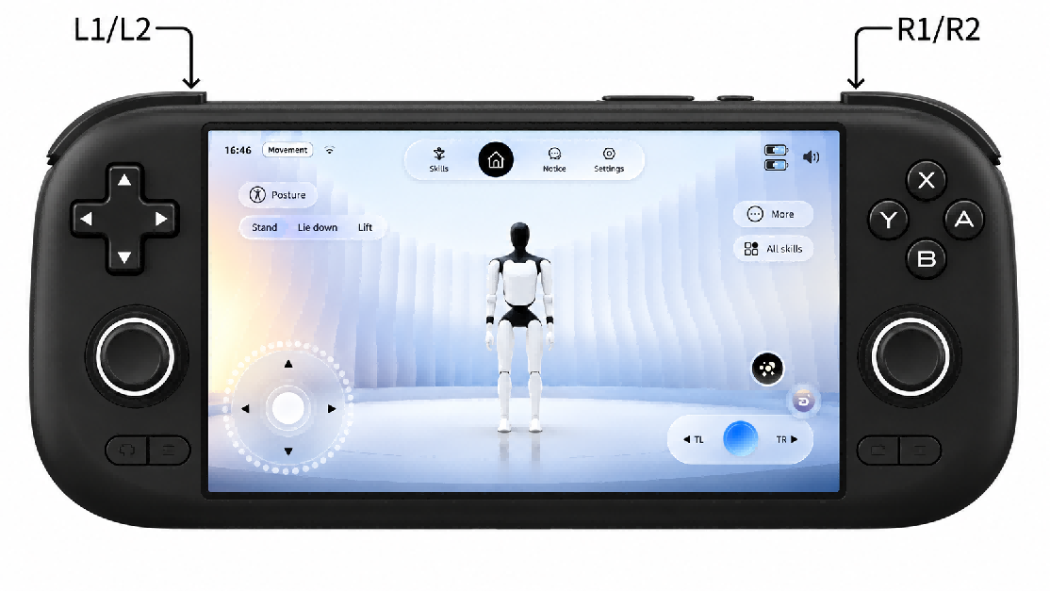
2. Operable items in the soft emergency stop state
After the robot enters the soft emergency stop state, only limited operations such as viewing the function list, alarm information, and reporting problems can be performed on the Emergency Stop page.
3. Steps to Exit the Soft Emergency Stop State
Restarting the robot to exit the soft emergency stop state
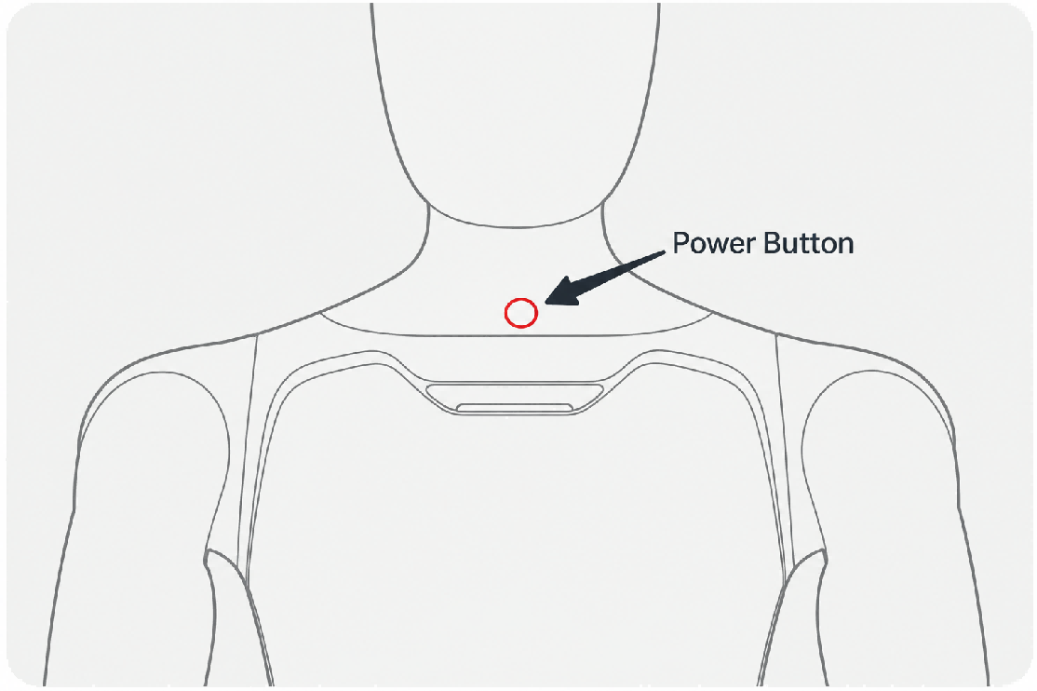

4.6.2 Emergency Stop Settings
Turn on/off the soft emergency stop function: On the [Settings] - [Movement] page of the App, you can turn on and off the software emergency stop function.
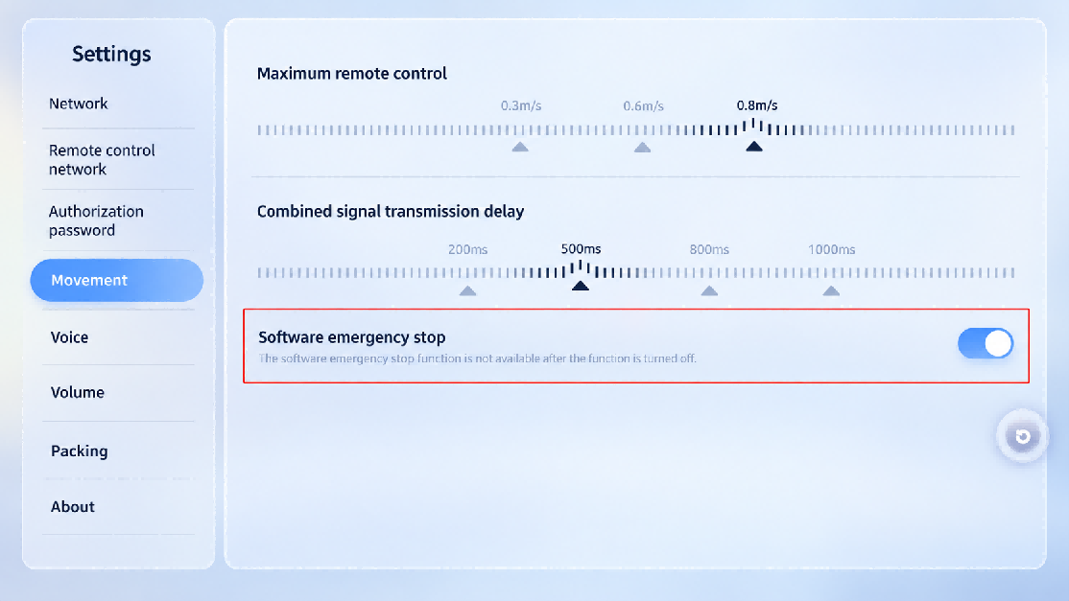

4.7 Lifting Ring Installation
• Step 1: Pull out the rubber plugs on both shoulders of the robot to expose the mounting slot
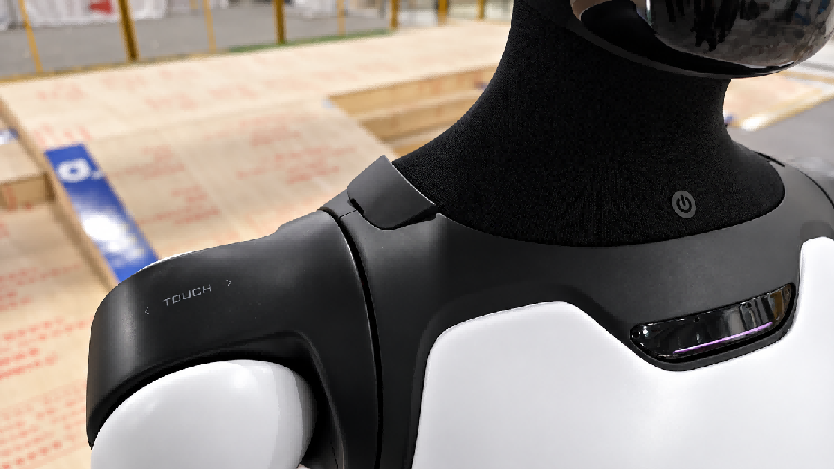
• Step 2: Hold the ring end and align the buckle end with the slot and press it firmly
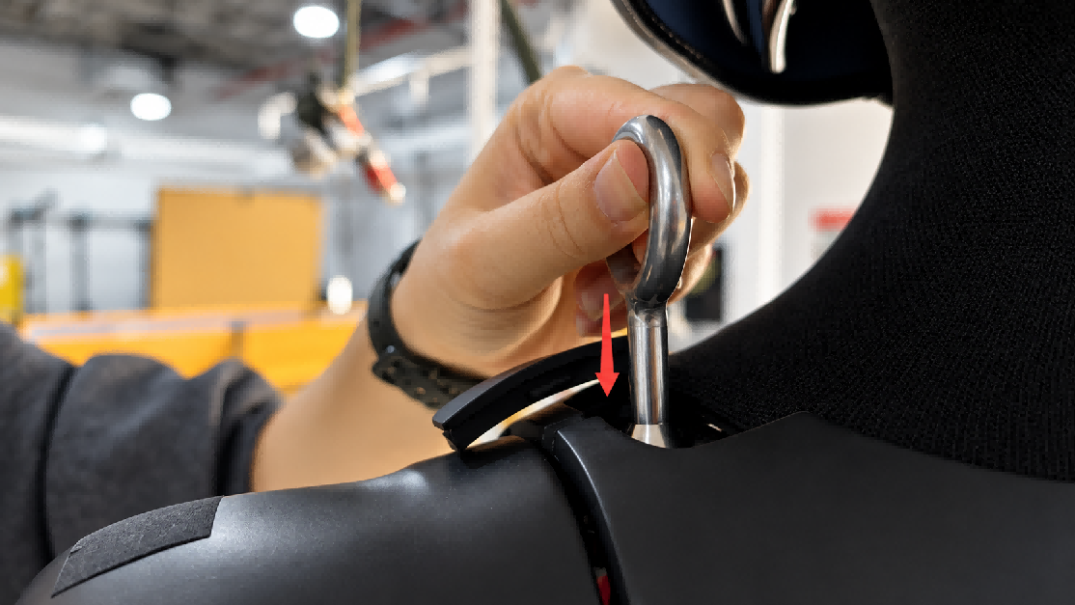
• Step 3: Rotate the lifting ring 90° and leave it there
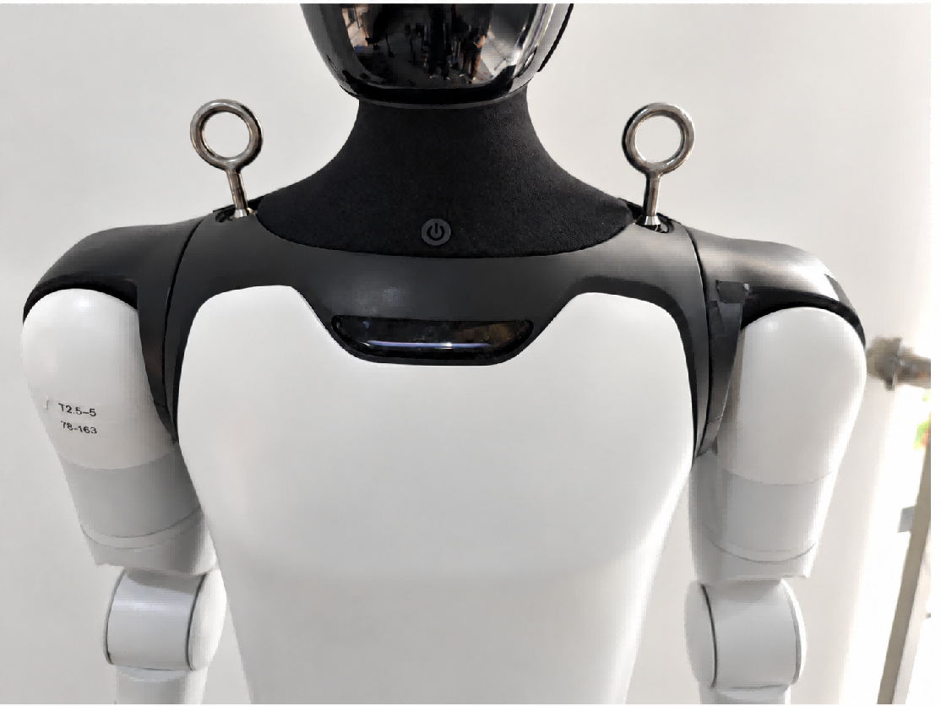

5. Function Description

5.1 Full-body Dance
Select the dance content from the skill set and slide to play
Step 1: Press the [Skills] the top tab bar
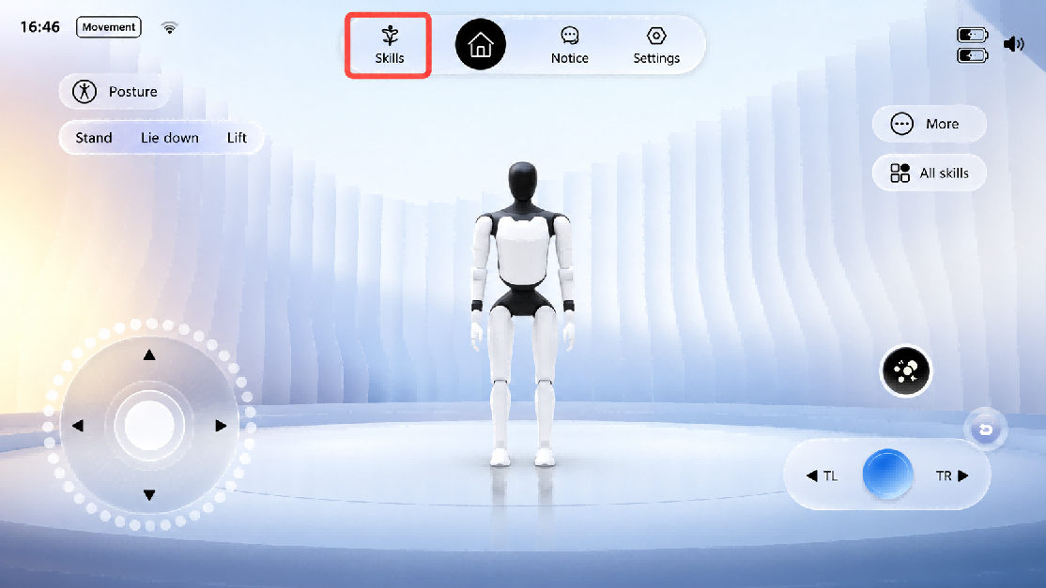
Step 2: Select the desired dance, and slide to execute
❗ Note: Dances need to be confirmed and executed according to pop-up instructions. Follow the tips to ensure safety.

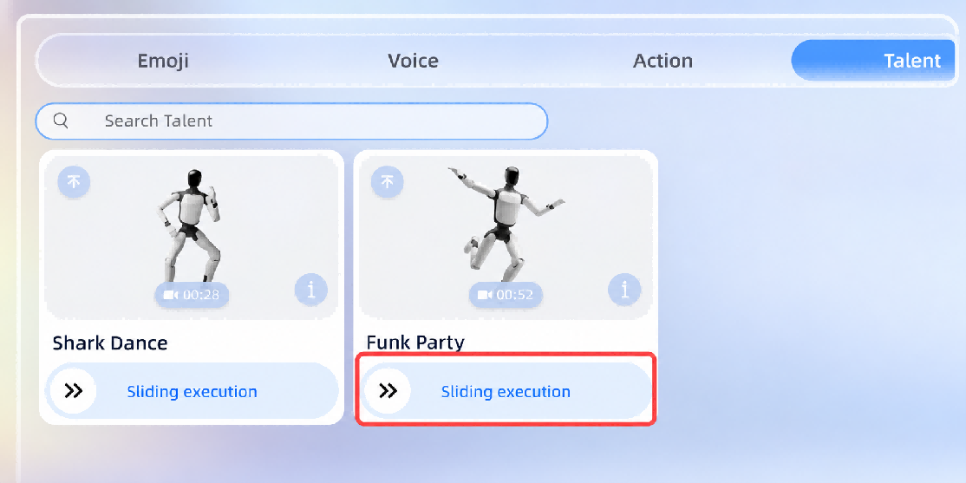

5.2 Body Actions
From the skill set the user can select different actions to play.

5.2.1 Upper-Limb Actions
On the client home page, tap Skills → Resource Management, then select an action to play.
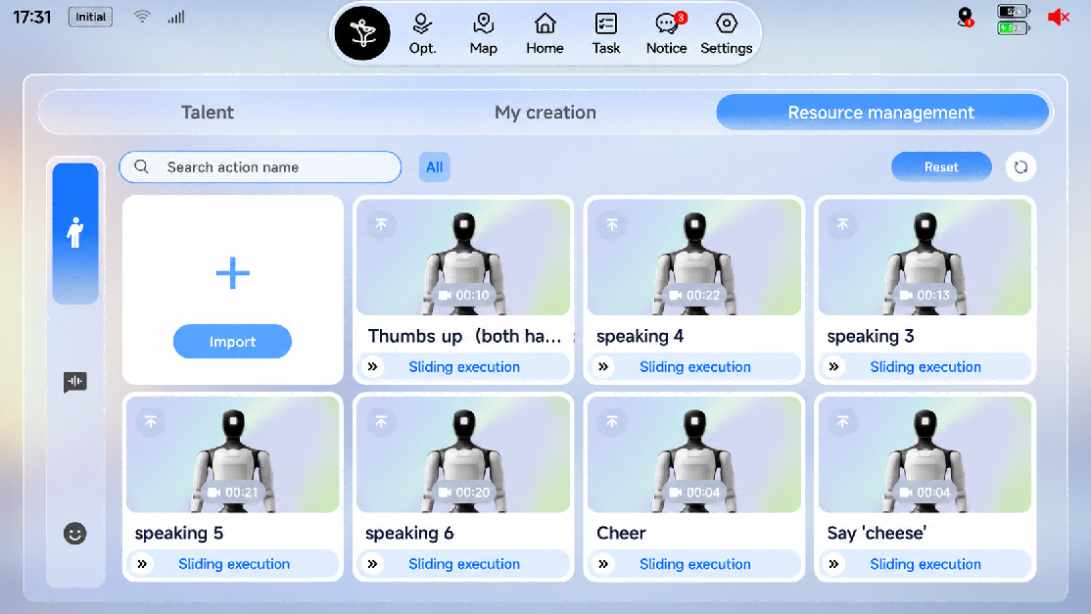

5.2.2 Upper-Limb Compliant Motion Playback (Passive Safety)
When this switch is turned on, the robot's arms become compliant, which reduces collision force.
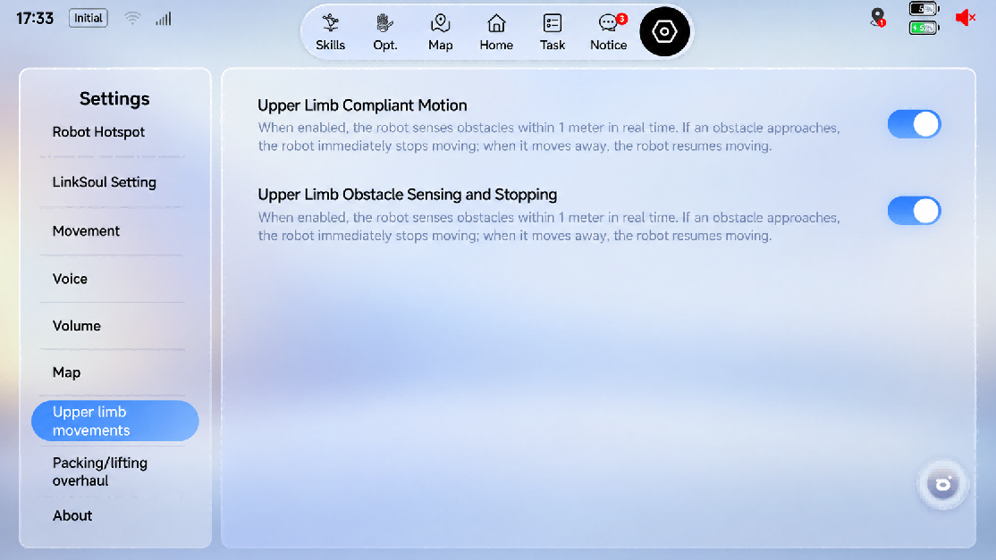

5.3 Robot Interaction
1. The robot provides two voice-interaction entry points, [Built-in Microphone] and [External Microphone], which can be switched in the Voice settings in the client.
2. Voice control of motions, dances, walking, and volume is supported, for example "Please shake hands", "Give me a dance", "Walk forward", "Set the volume to half", and "Set the volume to 30".
3. A newly added mute / interaction-disabled expression layer design (top-left corner of the screen), plus two new immersive expressions: entering the out-of-body avatar and the out-of-body avatar's ultimate move.
4. Multilingual interaction is supported, covering 16 languages including Chinese, English, German, French, Spanish, Japanese, Korean, Portuguese, Italian, Arabic, Thai, Russian, Malay, Vietnamese, Indonesian, Kazakh, and Turkish. Except for Chinese and English, the recognition rate of the other languages is approximately 65%–85%.
5. Speaker recognition is supported. Based on sound-source localization and visual information, the robot achieves "look at whoever is speaking" — turning its head / waist / whole body toward the user — and "knows who is speaking": for users with face ID, All-New Futurist can politely address them by name during wake-up responses and LLM chats. In complex environments with medium-to-high noise and multiple people, occasional positioning errors may occur; the [Interaction Full-Body Follow] switch under Client → [Voice] can be turned off.
6. More features will be added in future OTA updates. Please follow the release notes.

6. Accessories Management and Usage

6.1 4G/5G Module User Guide
Robots are equipped with built-in eSIM cards. For details on the specific installation and warranty services, please refer to Section 8.1 of this article.

6.1.1 eSIM Usage Instructions
• Communication standard: Supports 5G/4G.
• Plan: 100 GB of data per month. Once the data is used up, mobile network service stops; to continue using it, contact FF EAI Robotics after-sales to purchase a data add-on package.
• Free period: Up to 1 year. To continue using it after expiry, contact FF EAI Robotics after-sales to renew.
• Activation: Automatically activated after the device powers on.
• Network usage: The eSIM is enabled by default. When the device connects to Wi-Fi, the Wi-Fi network is used preferentially; when Wi-Fi disconnects, the mobile network is used automatically.

6.1.2 SIM Card Specifications
The All-New Futurist supports Micro-SIM cards for internet access. Its cellular communication module is compatible with 4G/5G protocols. Actual network availability may vary by service provider. Please refer to your sales contact for inquiries about SIM Card support.

6.1.3 SIM Card Purchase
Since some functions of the All-New Futurist need to access FF EAI Robotics servers, whitelist configuration is required. You need to purchase dedicated enterprise IoT SIM cards from FF EAI Robotics' partners.
The advantages of enterprise IoT SIM cards: no personal real-name authentication is required; only the business license and the front/back of the legal representative's ID card are needed. In addition, a unified SIM management platform is provided, which allows real-time monitoring of order / dispatch status, traffic usage, and balance / recharge information.

6.1.4 SIM Card Installation
On the neck of the device, the SIM card slot can be seen by removing the black silicone protective cover.
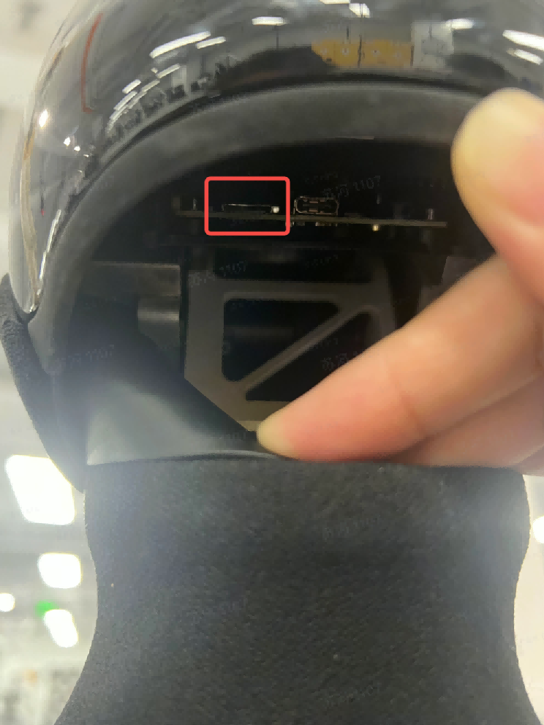

7. Daily Maintenance and Management
Compliance with the above instructions ensures safe and efficient operation of the robot. For any inquiries, please contact the manufacturer or authorized service provider for technical support.

Safety Warnings
1. Power-off Maintenance: Before any maintenance or component replacement, completely power off the device and confirm it is in a fully de-energized safe state.
2. No Unauthorized Modification: Do not modify the robot or alter its original design and configuration without official authorization.
3. Professional Repair Only: Do not disassemble the robot personally. If maintenance is required, contact the manufacturer's designated professional service personnel.

Maintenance and Upkeep
1. Routine Maintenance: Perform regular maintenance in accordance with FF EAI Robotics official recommendations to keep the robot in optimal operating condition.
2. Use Original Spare Parts: Only use manufacturer-specified original spare parts for component replacement to guarantee equipment performance and operational safety.

Fault Handling
1. Fault Response: Immediately stop operation once any malfunction occurs, and arrange for professional technicians to conduct inspection and repair.
2. No Unauthorized Disassembly & Repair: Do not disassemble or repair the robot by yourself, so as to prevent secondary damage to the device.

Battery and Power Management
1. Safe Charging: Do not disassemble the battery for separate charging; charge only by connecting the dedicated power supply.
2. Charging Environment: The robot's battery shall be charged in a safe, dry environment. Avoid humid and high-temperature surroundings.
3. Prevent Overcharging: Do not keep the device connected to power for a prolonged period to avoid battery overcharging and overheating, and to prolong battery service life.
4. Professional Battery Replacement: Battery replacement must be performed only by qualified professionals. Mismatched use of chargers for different battery types may cause fire hazards.
5. Dedicated Power Supply Only: Use only the supplied removable power supply for charging.
6. Battery Disposal: Remove the battery and dispose of it in accordance with safety regulations before scrapping the device.

Software Management
1. Regular Software Updates: Regularly check and upgrade the robot's operating system and control software to fix potential vulnerabilities and enhance system security.

8. After-sales Service Policy

8.1 Warranty Content
For details of the warranty content, please refer to https://www.ff.com

8.2 App Privacy Policy
Welcome to the App. The App and its related services (the "Products and Services") are developed and operated by FF AI-Robotics Inc. ("we" or "us"). We fully understand the importance of protecting the personal information and privacy of users ("you"). This Privacy Policy ("this Policy") sets out the rules governing how we collect, use, store, and protect your personal information when you access and use our Products and Services.
Please read this Policy carefully and make sure you fully understand all of its rules and key points (especially those presented in bold) before using our Products and Services. If you do not agree with this Policy or any of its terms, you should stop using our Products and Services. Once you choose to use them, you are deemed to have fully read and agreed to all contents of this Policy.
This policy helps you understand:
1. How we collect and use your personal information
2. How we share, transfer, and disclose your personal information
3. How we use cookies and similar technologies
4. How we store your personal information
5. How we protect your personal information
6. How we protect the personal information of minors
7. Your rights
8. How this Policy is updated
9. Contact us
1. How we collect and use your personal information:
In accordance with applicable laws and regulations, and strictly following the principles of legitimacy, lawfulness, and necessity, we collect and use the personal information you actively provide or that is generated when you use our Products and Services, in order to provide you with better products and services.
1. When you register for or log in to an account, we collect the username, phone number, and other information you provide, and may verify your identity via SMS or email.
2. When necessary, we verify your true identity to comply with laws, regulations, and regulatory requirements and to ensure user security.
3. When you contact us, we save your call records, call content, or contact information so that we can reach you, resolve issues, and record the handling plan and results.
2. How we share, transfer, and disclose your personal information:
Circumstances requiring your prior authorization or consent — we may share, transfer, or disclose your personal information to third parties in the following circumstances:
1. As provided in this Policy or upon your explicit consent or authorization;
2. As required by applicable laws and regulations, legal procedures, or mandatory administrative or judicial requirements;
3. To the extent permitted by laws and regulations, to protect the interests, property, or safety of us, our affiliates, you, other users, or the public from harm;
4. To implement functions related to the Products and Services or to provide the services you request;
5. For use in academic research;
6. Where you have violated this Policy and we provide information to third parties for the purpose of protecting our rights.
Circumstances not requiring your prior authorization or consent — we may share, transfer, or publicly disclose your personal information without your prior authorization or consent in the following circumstances:
1. Where necessary to perform statutory duties or obligations, such as duties or obligations directly related to national security, defense security, criminal investigation, prosecution, trial, and execution of judgments;
2. Where it is necessary to protect the vital interests of life or property of you or other individuals but it is difficult to obtain your consent;
3. Personal information that you have voluntarily disclosed to the public;
4. Personal information collected from lawfully public information, such as lawful news reports or government information disclosure;
5. Where necessary to conclude and perform a contract at your request;
6. Where necessary to maintain the safe and stable operation of the Products or Services, such as discovering and handling faults;
7. Personal information that has been technically processed so that the recipient cannot re-identify a specific individual and cannot restore it; or personal information that we have de-identified in order to improve products and services;
8. Other circumstances stipulated by laws and regulations.
3. How we use cookies and similar technologies:
Cookies and similar technologies are common technologies used on the Internet. When you access our Products and Services, we may use such technologies to send one or more Cookies or anonymous identifiers to your device to collect and store information about your access to and use of our Products and Services. They will not be used for any purpose other than those described in this Policy, mainly to achieve the following functions:
1. Ensuring the secure and efficient operation of the Products and Services: setting authentication and security Cookies or anonymous identifiers to confirm whether you are safely logged in, to distinguish whether you have encountered account theft, fraud, or other unlawful acts, and to improve service efficiency and login and response speed;
2. Helping you enjoy easier access: eliminating the need to repeatedly fill in personal information or enter search content;
3. Clearing Cookies: most browsers provide the function of clearing cached data; you can clear Cookies in your browser settings, but after clearing, functions or services that rely on Cookies may become unavailable.
4. How we store your personal information:
1. In accordance with laws and regulations, we store the personal information collected and generated during operation within the People's Republic of China. At present, such information will not be transferred overseas; if overseas transfer is required, we will follow relevant national regulations or seek your consent.
2. We retain your personal information only for as long as necessary to provide the Products and Services. Beyond the necessary period, your personal information will be deleted or anonymized, unless retention is extended based on your needs or as permitted or required by laws and regulations.
5. How we protect your personal information:
1. We attach great importance to the security of your personal information and will strive to take reasonable technical and administrative security measures to prevent your personal information from being improperly used or from being accessed, publicly disclosed, used, modified, damaged, lost, or leaked without authorization.
2. You should understand that although we have taken reasonable and effective measures and comply with the standards required by relevant laws, due to technical limitations and possible malicious means, the absolute security of information cannot always be guaranteed.
3. In the event of a user information security incident, we will, in accordance with laws and regulations, promptly inform you via push notifications, email, letters, SMS, or other means of the basic situation and possible impact of the incident, the measures taken or to be taken, suggestions for you to prevent and mitigate risks on your own, and remedial measures for you. Where it is difficult to notify each user individually, we will issue an announcement in a reasonable and effective manner. We will also report the handling of the incident to the relevant regulatory authorities as required.
6. How we protect the personal information of minors:
1. If you are a minor under the age of 18, you should read and agree to this Policy under the supervision and guidance of your parents or other guardians before using our Products and Services. If your guardian does not agree to your use of our Products and Services under this Policy or to your provision of personal information to us, please stop using our Products and Services immediately and notify us promptly to delete your personal information.
2. If you are the guardian of a minor and have questions about the processing of the minor's information under your guardianship, or if the minor under your guardianship uses our Products and Services or provides personal information without your consent, please contact us through the methods described in this Policy so that we can take appropriate measures.
7. Your rights:
We attach great importance to your management of personal information and do our utmost to protect your rights relating to your personal information:
1. Changing or withdrawing the scope of authorization: You can turn off relevant permissions in the product's operating system, change the scope of consent, or withdraw your authorization. After withdrawal, we will no longer collect information related to those permissions. Certain business functions and services require your information to complete; after you withdraw consent or authorization, we will be unable to continue providing the corresponding services and will no longer process your relevant personal information. However, your withdrawal does not affect the collection, processing, and use of information previously carried out based on your authorization.
2. Account cancellation: If you wish to cancel your account, please contact us through the methods described in this Policy, and we will process your request promptly. Before canceling your account, we may verify your identity, security status, device information, etc.; you agree to authorize and cooperate with our account cancellation process. After your account is canceled, we will delete or anonymize your personal information in accordance with this Policy, except as otherwise provided by laws and regulations.
3. Other rights related to personal information: If you believe that your personal information rights may have been infringed or wish to exercise other rights related to personal information, you may contact us through the methods described in this Policy, and we will respond promptly after receiving your request, except as otherwise provided by laws and regulations.
8. How this Policy is updated:
1. We have the right to modify, supplement, or update this Policy from time to time and publish it in an appropriate manner. For major changes, we will also provide more prominent notice (such as official announcements, push notifications, SMS, or email).
2. If you choose to continue using our Products and Services, you must re-agree to the revised contents of this Policy. Please pay attention to and stay informed about revisions; if you do not agree with the revised version, you should immediately stop using the Products and Services we provide.
3. Major changes referred to in this Policy include, but are not limited to:
4. Changes to the main recipients of personal information sharing, transfer, or disclosure;
5. Major changes to your rights regarding the processing of personal information and how to exercise them;
6. Changes to the department responsible for personal information security, contact information, and complaint channels;
7. When a personal information security impact assessment report indicates high risk.
9. Contact us:
If you have any questions, comments, or suggestions about this Policy, you can contact us in the following ways:
a. After-sales support: support.ff.com
b. After-sales email: support@ff.com
We will respond to your questions, comments, or suggestions promptly and help resolve your issues.

